DRAFT

TOWN BOARD MEETING
JANUARY 14, 2015
7:00 PM

Supervisor Jamieson opened the meeting 7:05 PM followed by a salute to the flag. Members present: Supervisor Jamieson, Councilman Murray, Councilwoman Ranni, Councilwoman Smith, Councilman Valentine

Also present: Engineer Al Fusco

AUDIT OF CLAIMS

A MOTION WAS MADE BY Councilwoman Ranni and seconded by Councilwoman Smith and passed 5-0 to approve payment of the bills in the following accounts:

GENERAL FUND $265,469.20
GENERAL – PART TOWN 101,296.46
HIGHWAY – TOWN WIDE 36,786.81
HIGHWAY – OUTSIDED 4,059.10
FIELDCREST WATER 1,387.53
LAKE HILL FARMS WATER 3,926.79
SUGAR LOAF HILLS WATER 1,771.53
SURREY MEADOWS WATER 3,752.26
GARBAGE DISTRICT 47,151.00
TRUST & AGENCY 9,398.75
WALTON LAKE WATER 3,761.36
$478,760.79

COMPREHENSIVE PLAN PUBLIC HEARING CONTINUATION

Supervisor Jamieson opened the floor for additional comments on the Comprehensive Plan Update: 2014.

Lenny Silver

Mr. Silver read from his written comments to the Board. Their entirety follows:

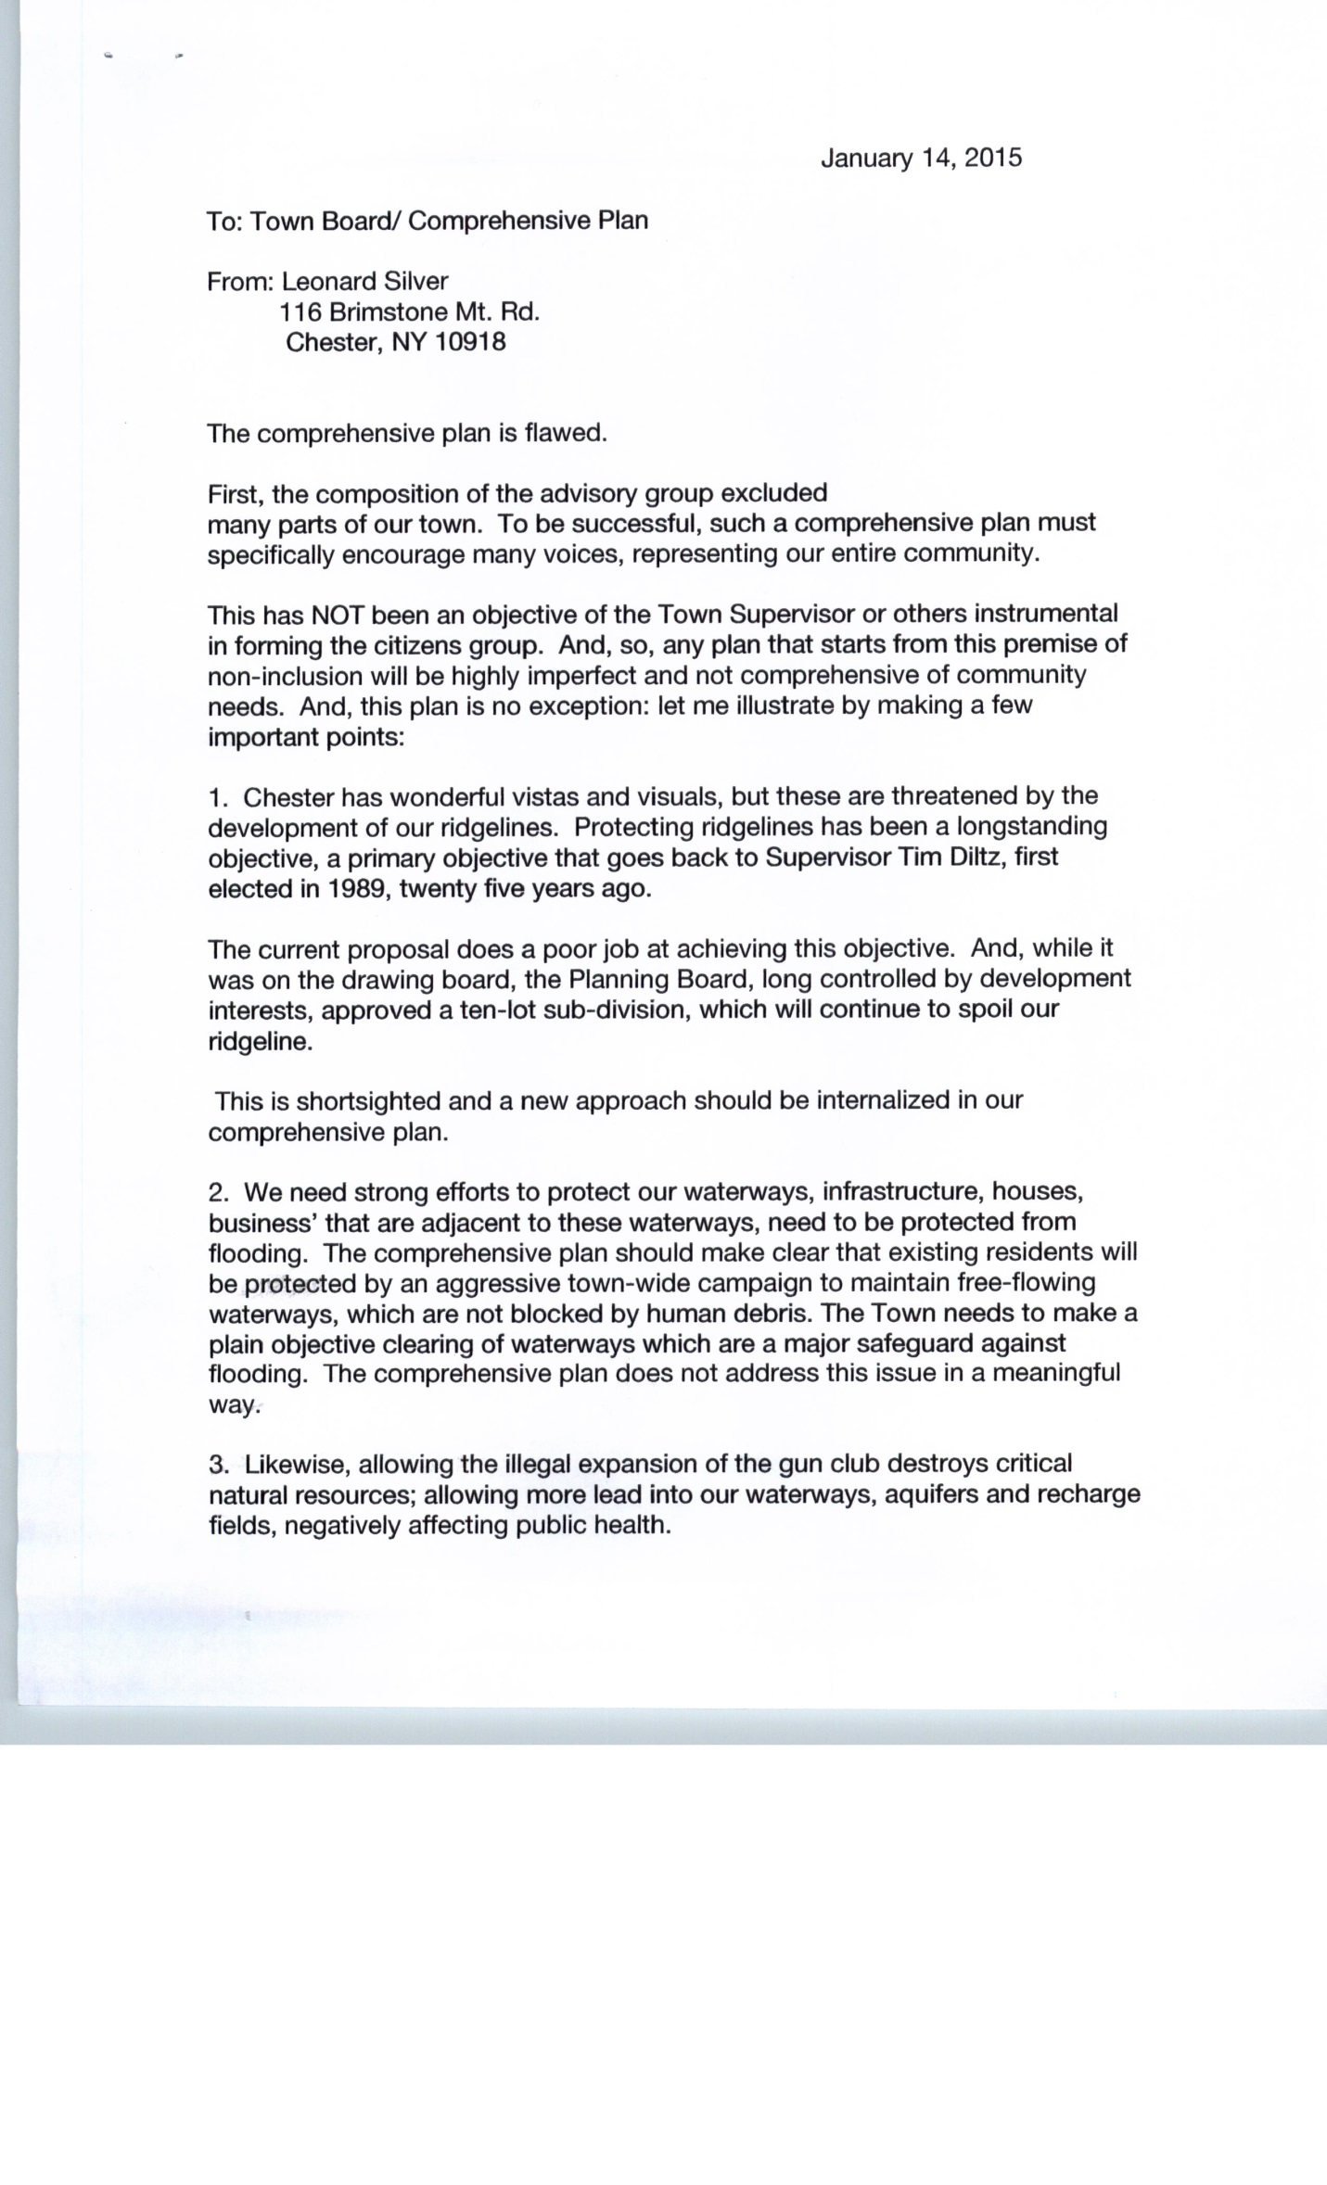
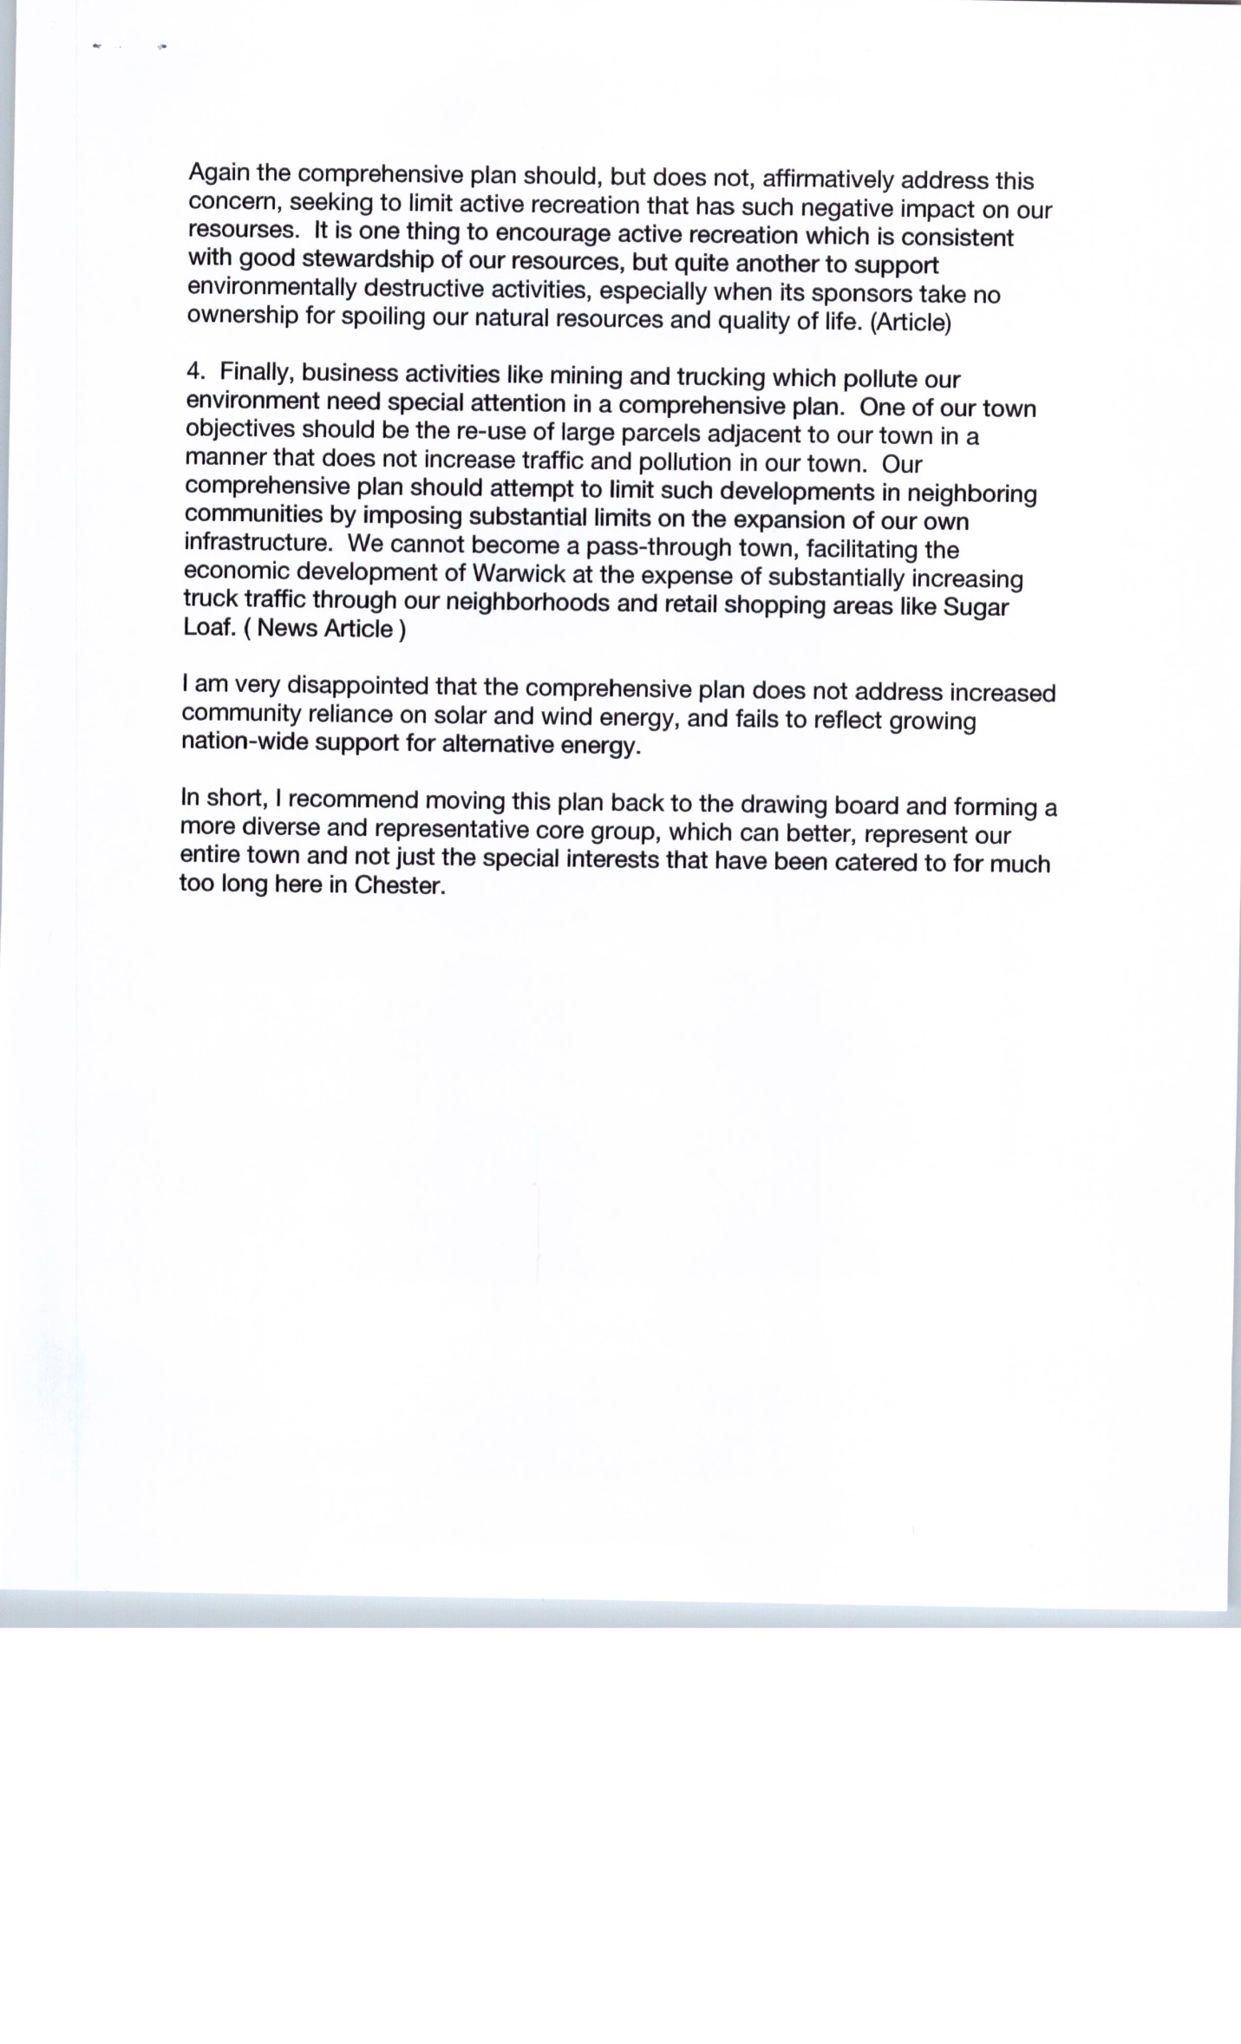
Tracy Shuh of the Preservation Collective, Inc. summarized their comments with regard to the Comprehensive Plan. She stated the letter is a follow up to their comments submitted at the Committee’s public hearing held in March 2014. She noted that the comments did not include what was good about the Plan. The updated Plan added the concern of transferring lots from another Town and making sure the Planning Board uses realistic lot counts. She made note that the Plan recognizes problems but solutions are vague and changes from “required” to “encourage” gives the public the impression it is less effective. She said she understood, however, that the zoning regulation changes would make the difference and she stressed follow-through on the Town’s Board part to oversee what comes through the Planning Board, ZBA and Building Department. In closing she asked the Town to keep things moving in a positive direction and inform the public and be open to their input. The letter follows in its entirety: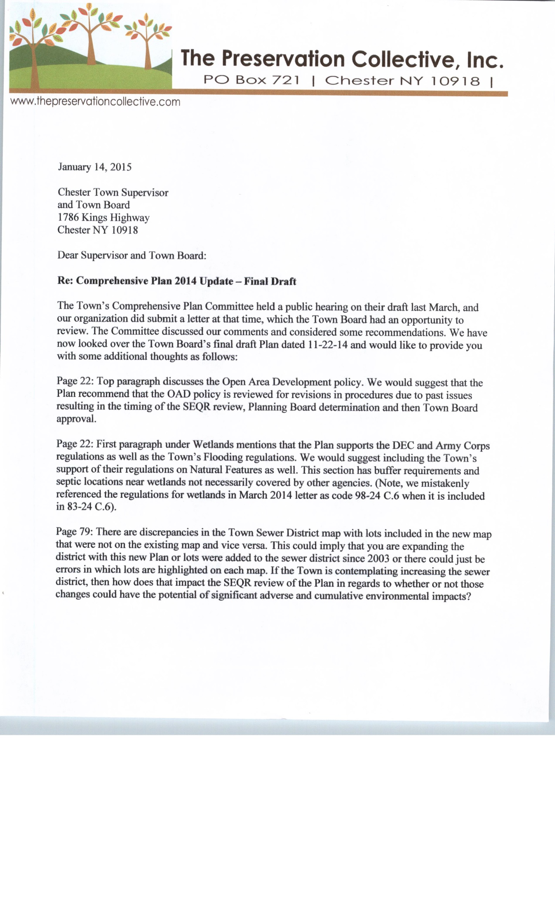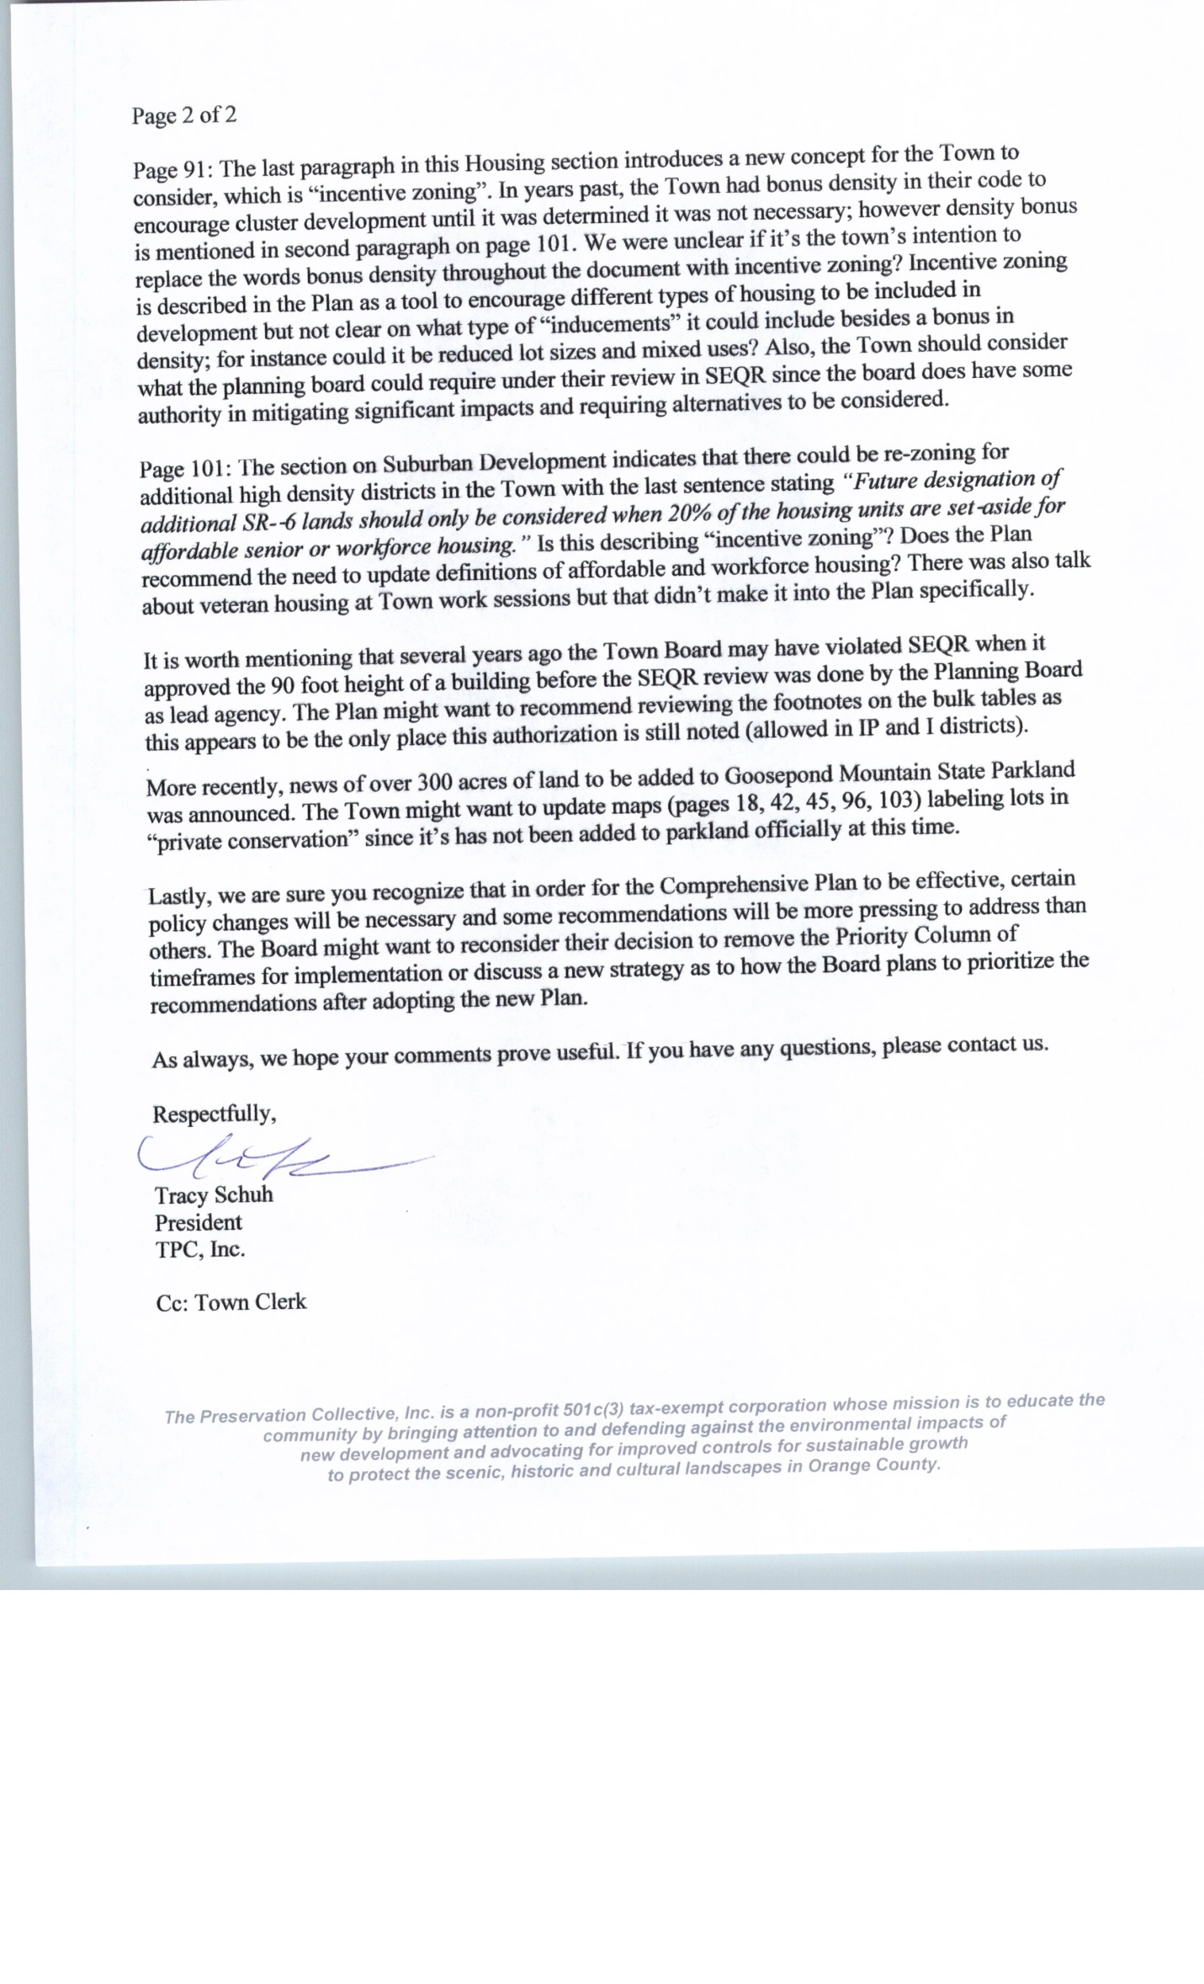Emily Boardman

Ms. Boardman acknowledged the good and responsible work done on the Plan. She expressed concerns with regard to the gun club. She noted that the gun club has not had any representatives in attendance. For the record, she stated it is hard for her to understand why for over 30 years there hasn’t been an opportunity to hear from the Board their position with regard to the gun club and no statement brought by the gun club. She said her experience with three bullets was more than one should have to address. She wanted a public statement to be put on the record that it is time for this entity to join with the public and look at the concerns. She commented that last Thursday, there was a volley of bullets in her home. She asked the Board to remember how it was.

Supervisor Jamieson asked for the letter submitted on behalf of Stanley Felsinger be read into the minutes. It follows in its entirety:

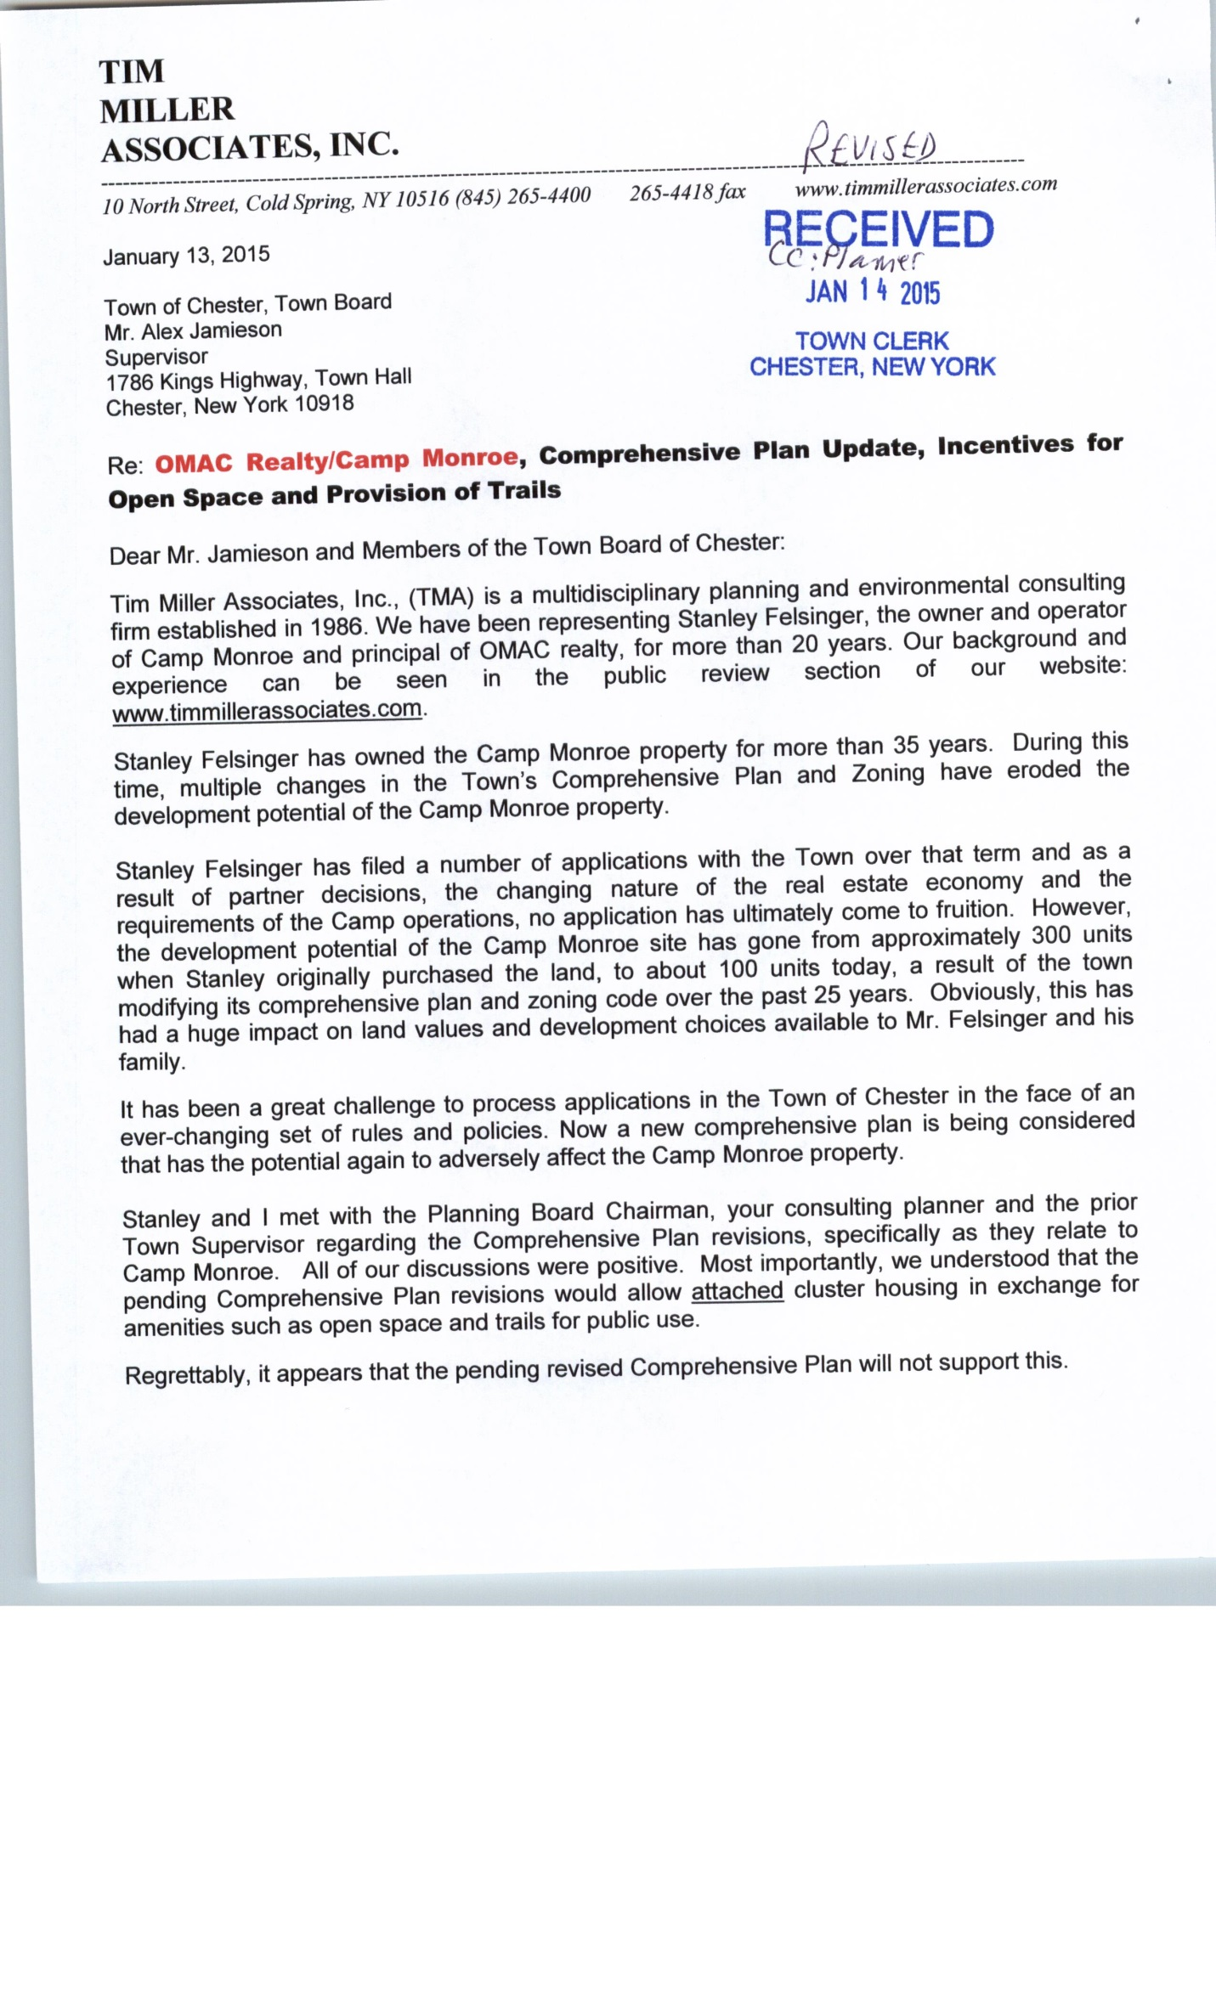
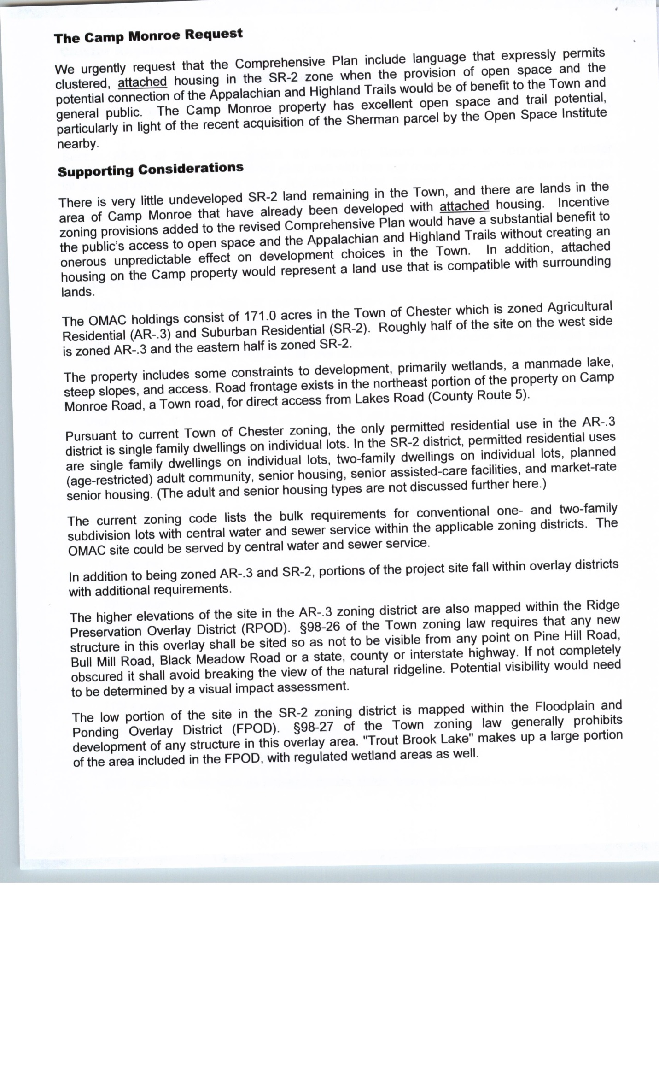
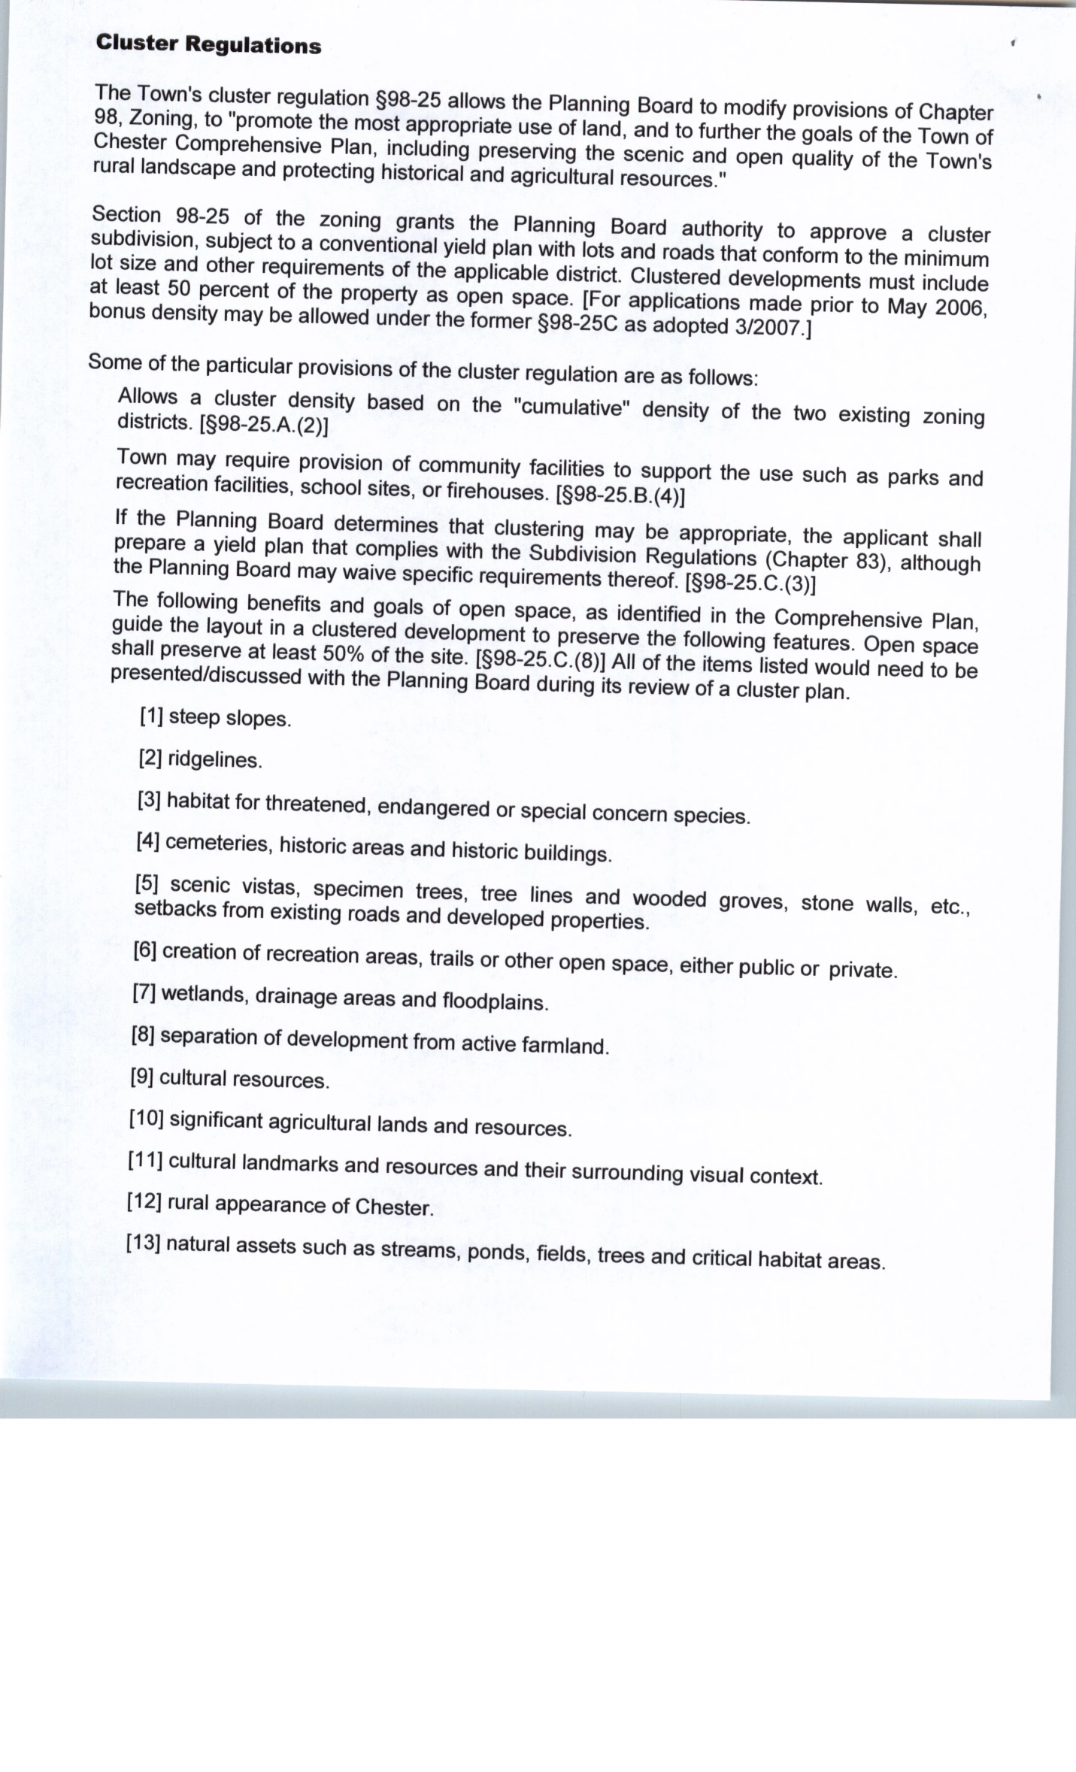
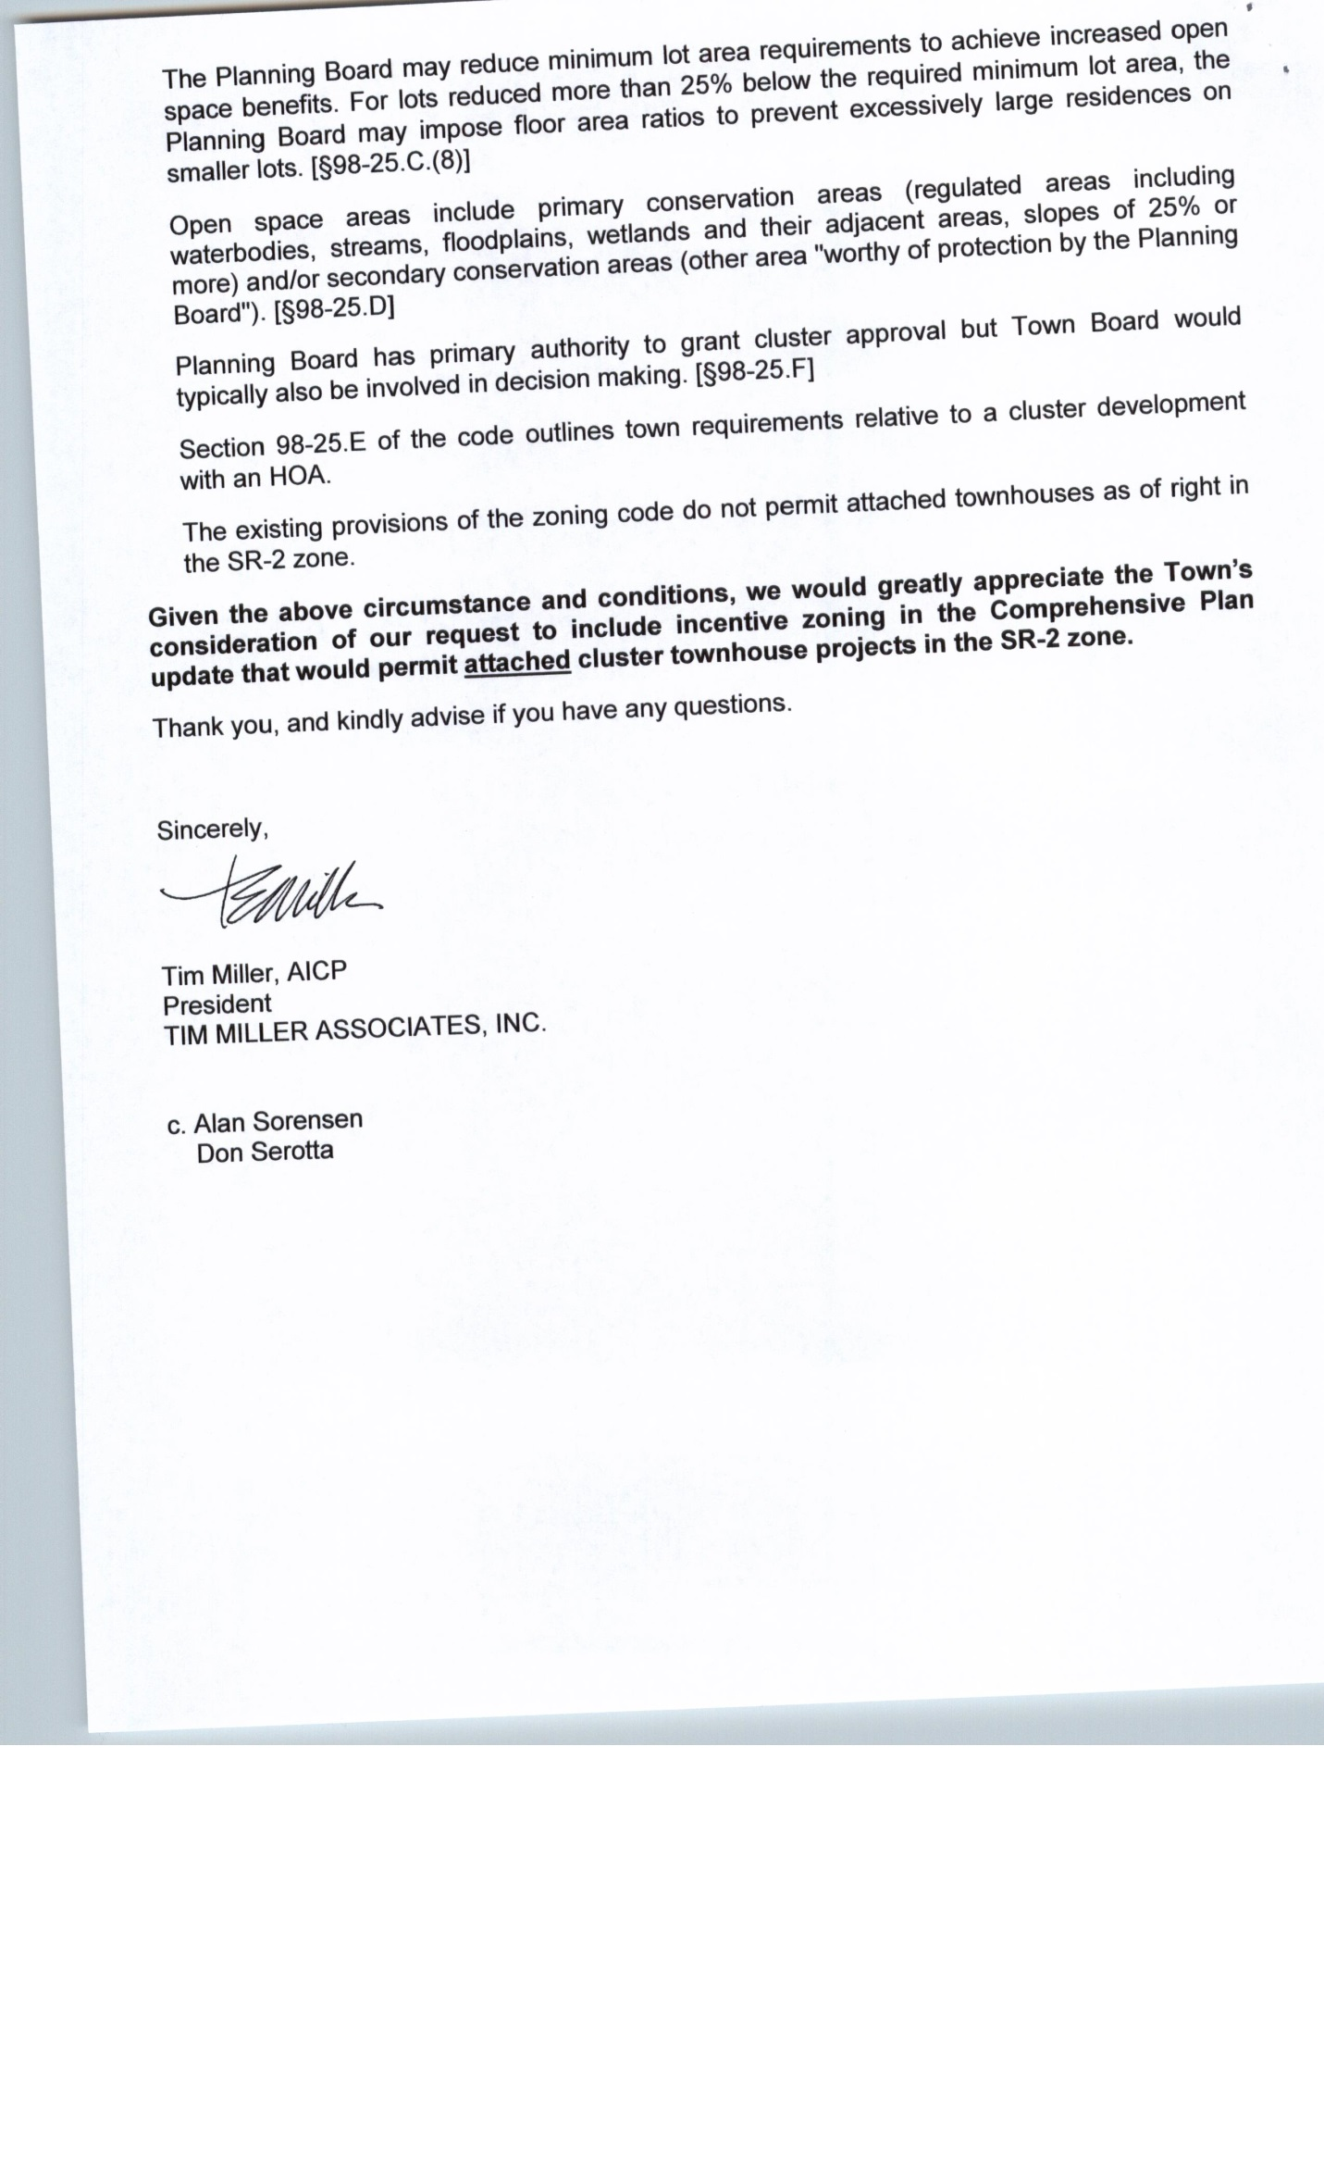
For the record, additional written comments received previously follow in their entirety:
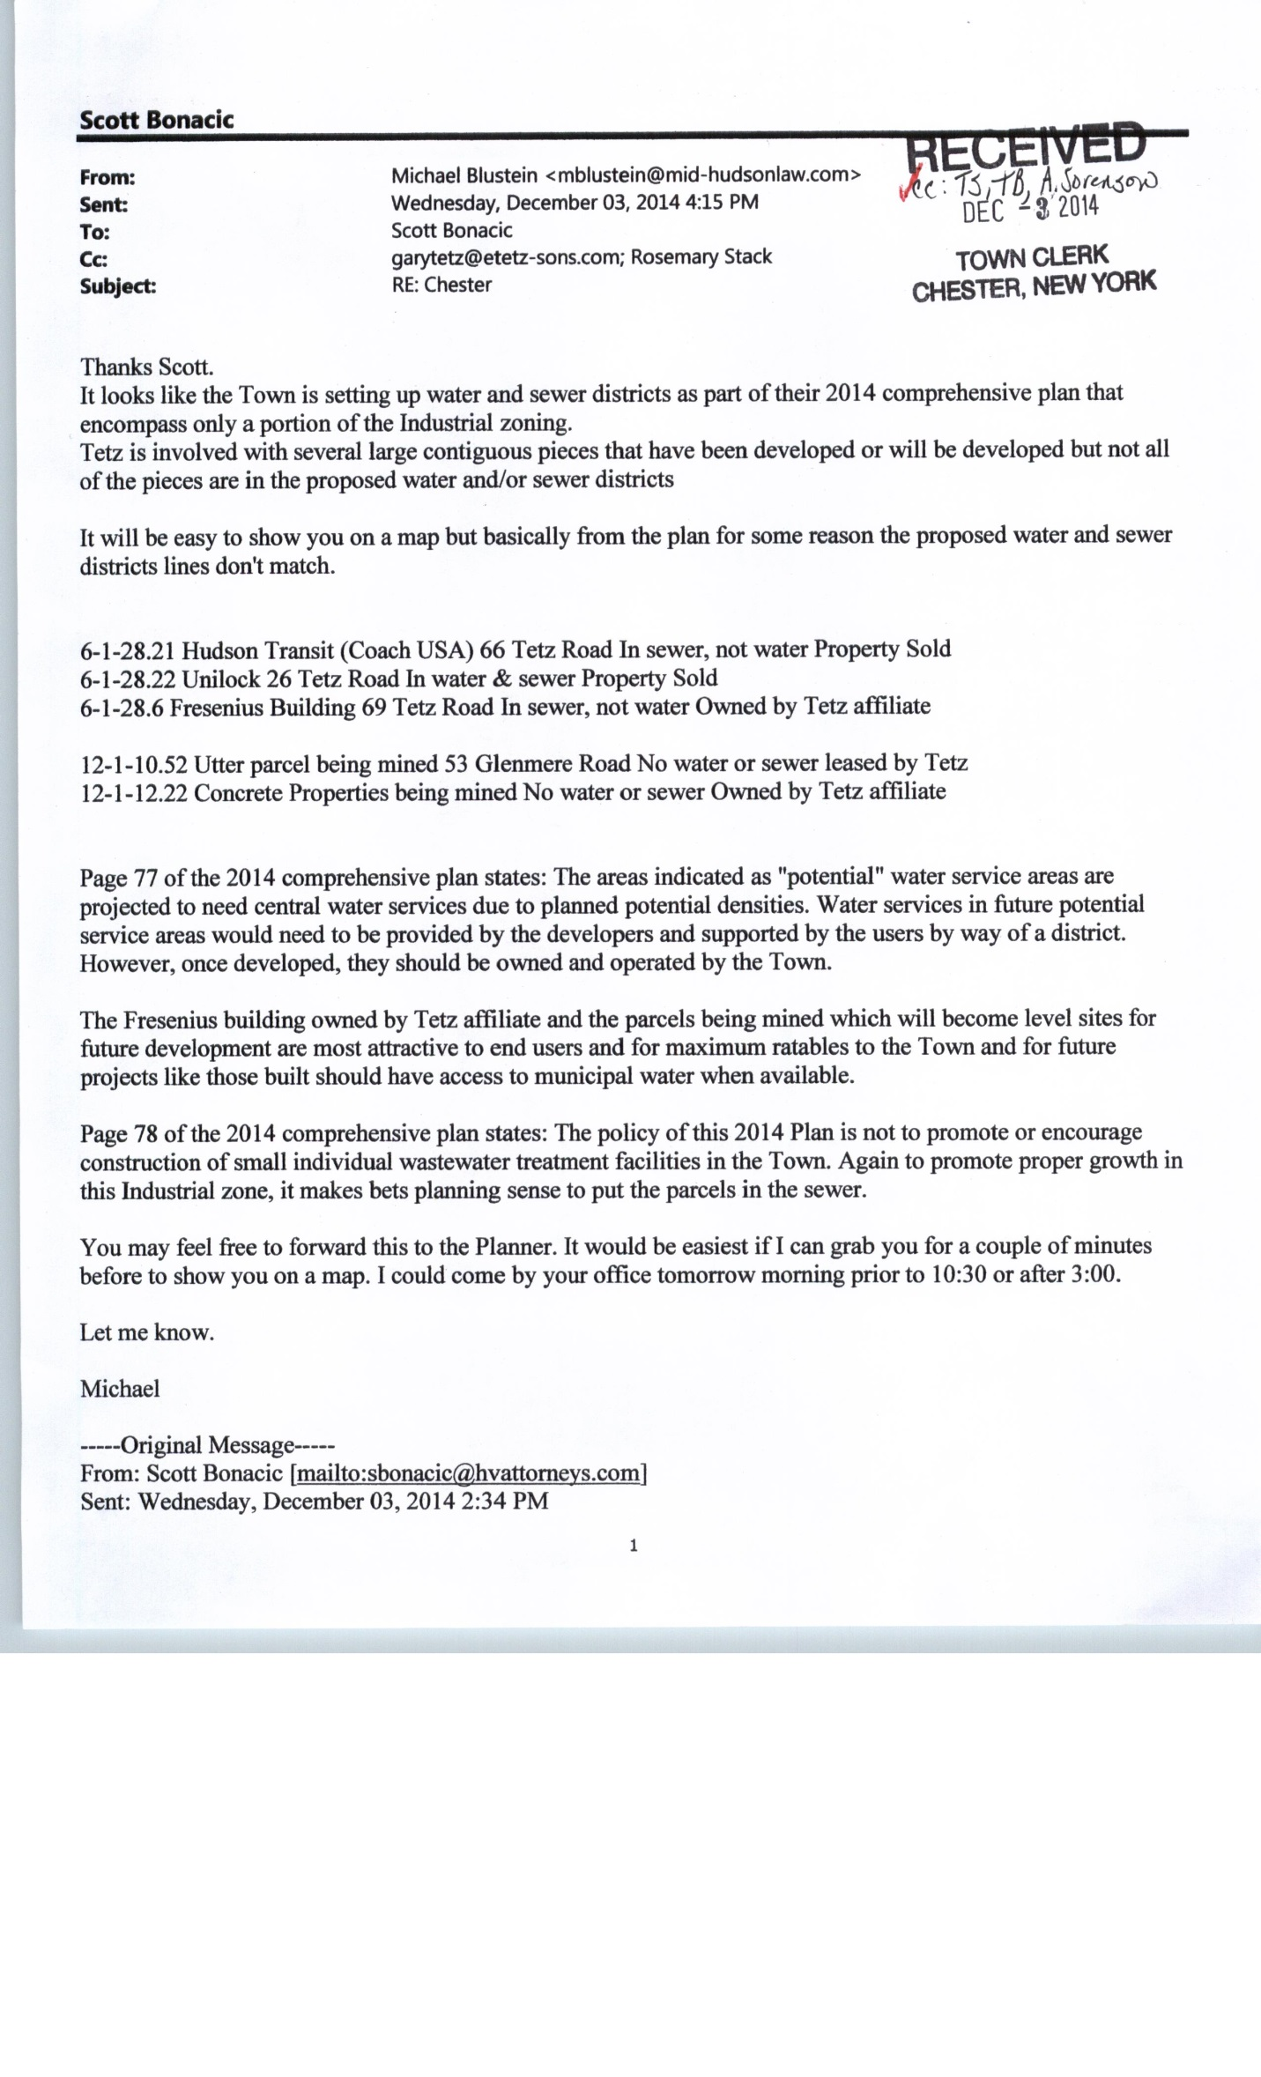
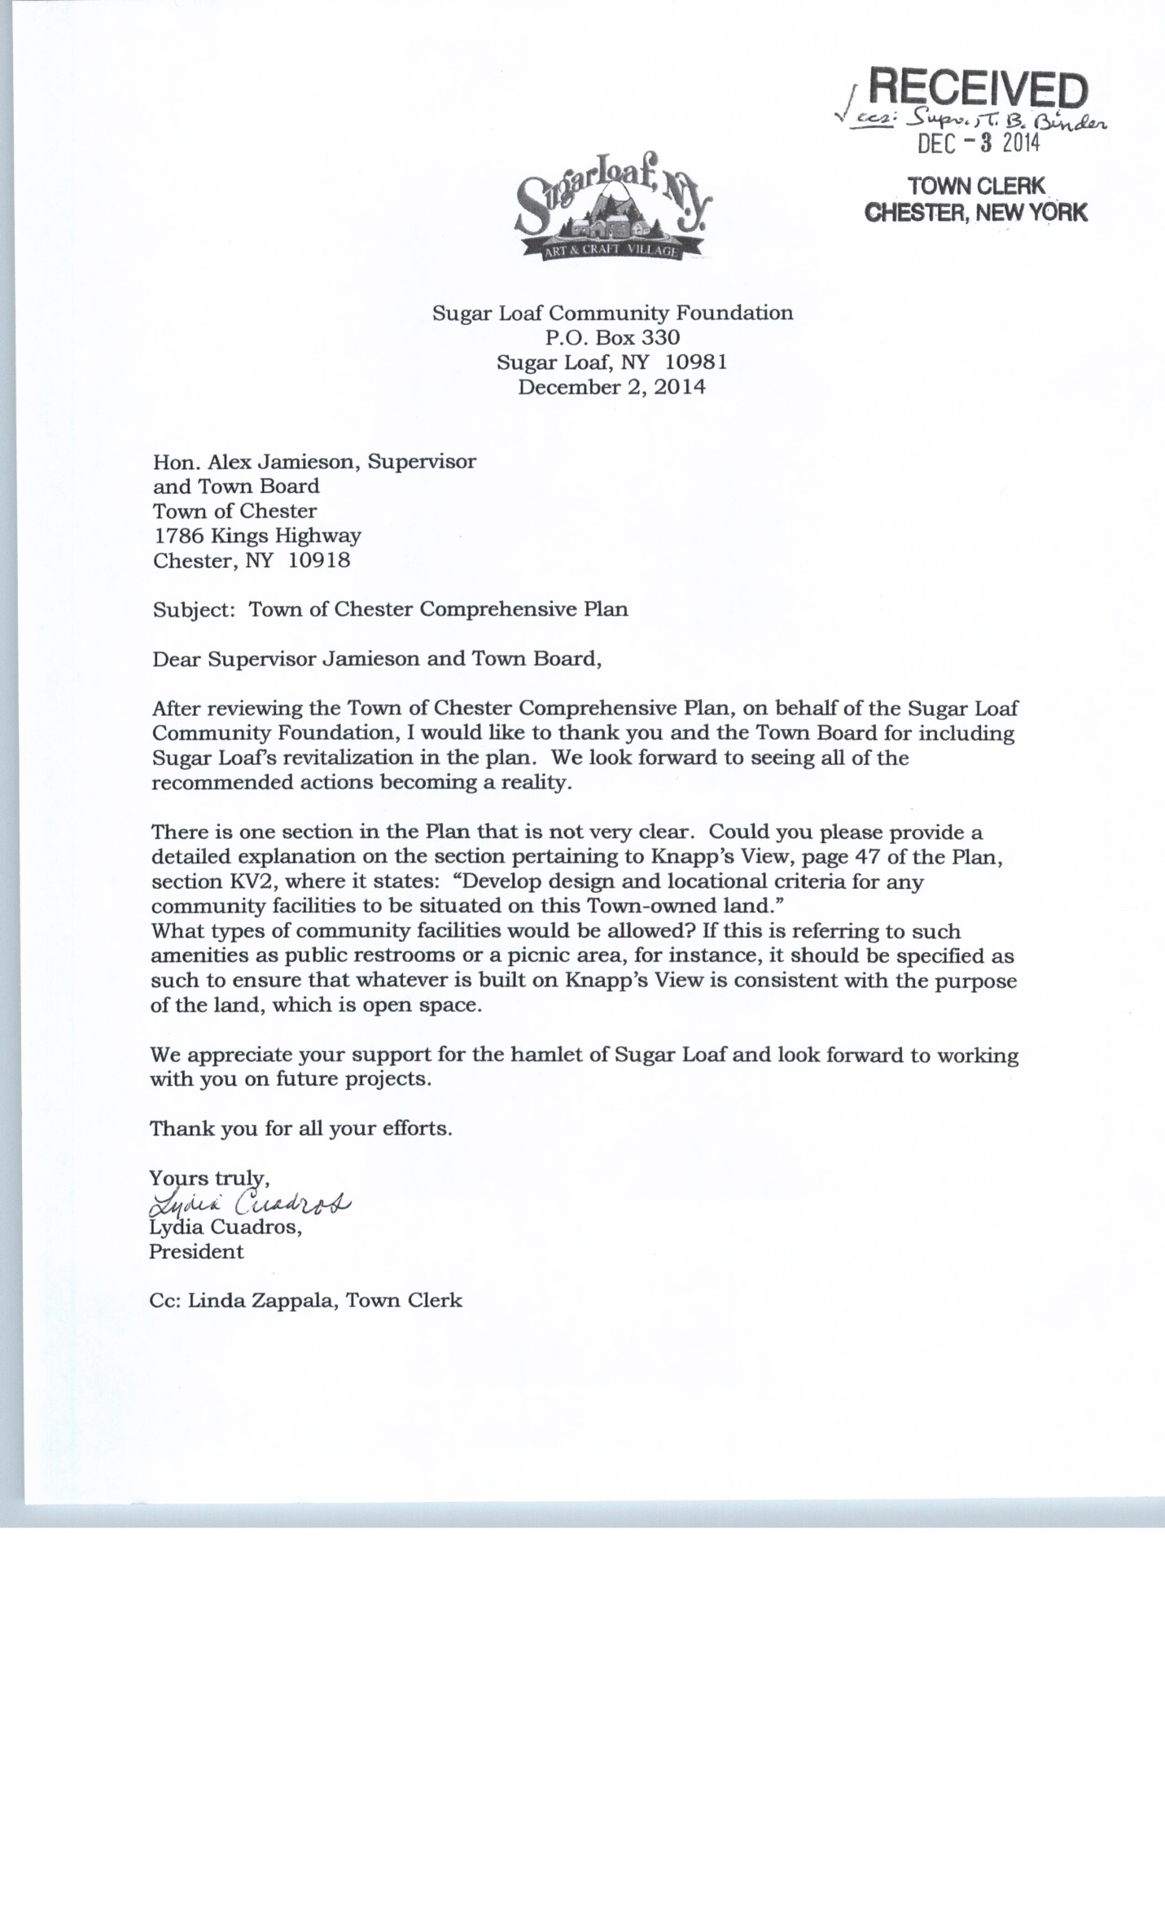

Supervisor Jamieson said the Town is not in a rush to move forward. He said, for one, the Town wants to make sure that the ridgeline is protected. Other issues of concern are projects including private sewer plants. He said the Comprehensive Plan will address pocket plants. He said the County will be increasing the sewer capacity in Harriman for the Camp LaGuardia project. This will require tweaking of the Plan. He said this is all about our town and it is to make the town better, as in the recent purchase by the Open Space Institute. The Town will keep the discussion open and not finalize it until it is complete. Upon any edits to the Plan, another hearing will be held. A MOTION WAS MADE BY Councilman Murray and seconded by Councilwoman Smith at 7:25 p.m. to close the Public Hearing on the Comprehensive Plan. Motion carried 5-0. Discussion: A continuing discussion concerning the Comprehensive Plan edits will be held on February 25, 2014.

Continuation of the Public Hearing concerning the Proposed Local Law on Digital Signs and Billboards

Supervisor Jamieson opened the floor to further comments regarding the Proposed Local Law on Digital Signs and Billboards. There were no comments to the floor. The following are written comments, in their entirety, received during and previously, regarding the proposed law.

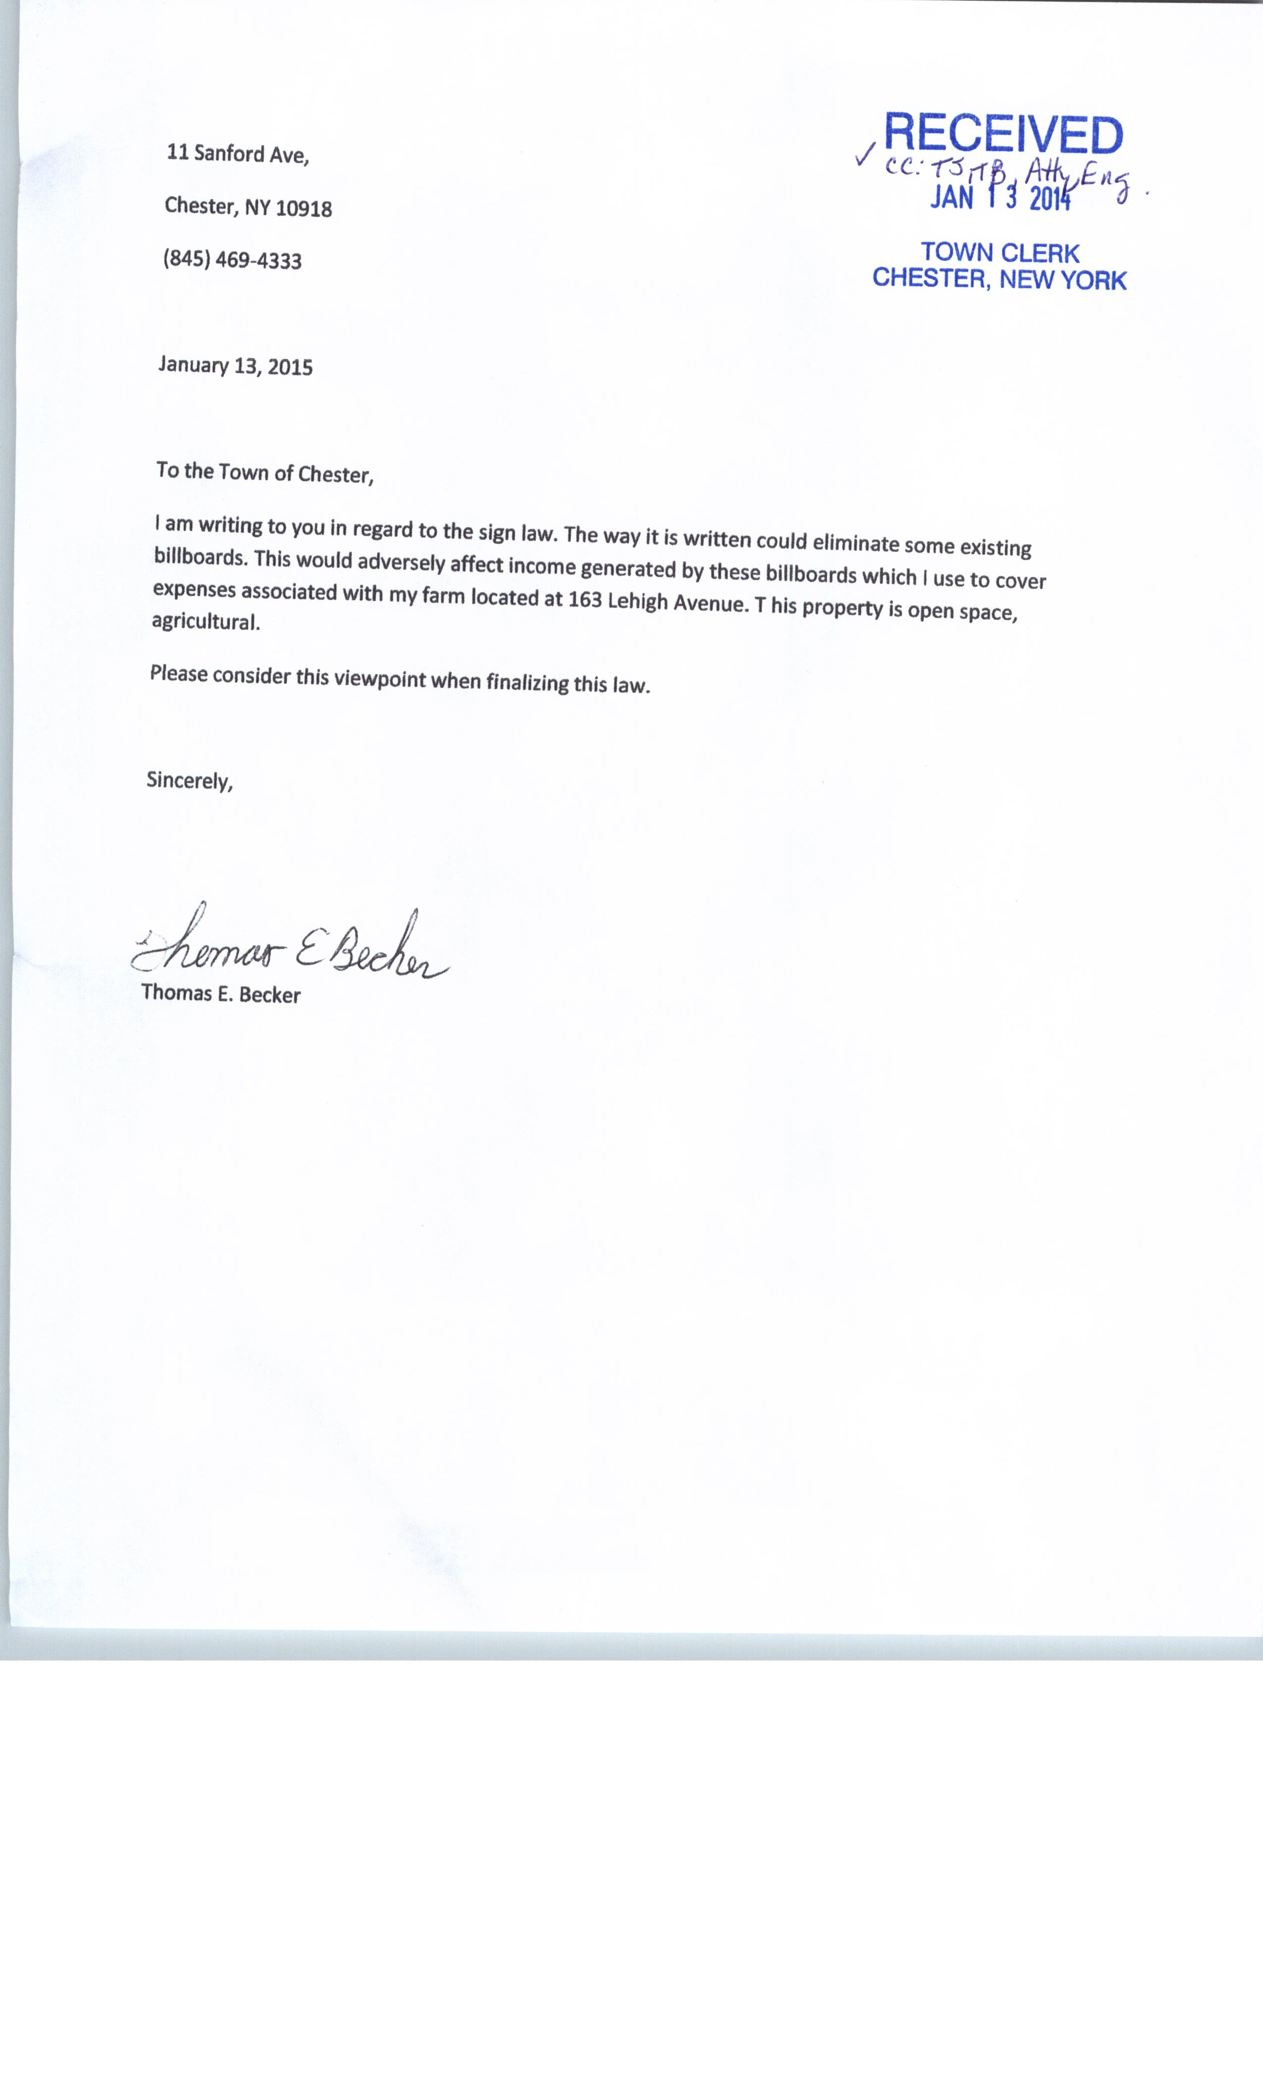
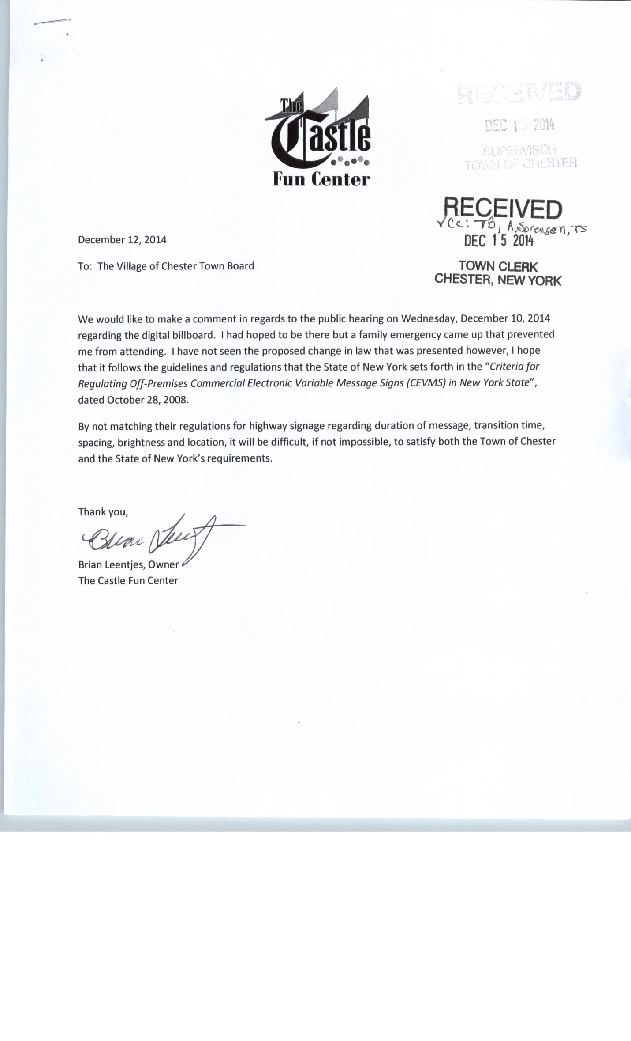
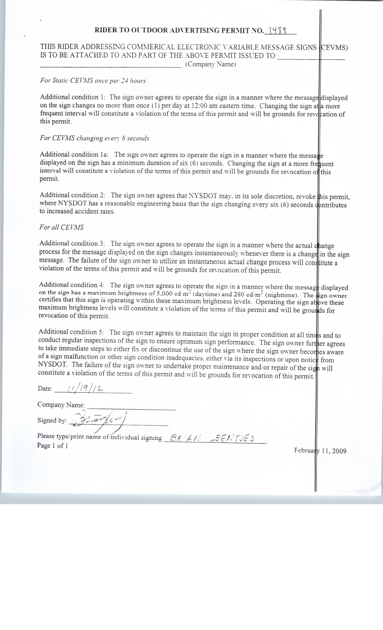
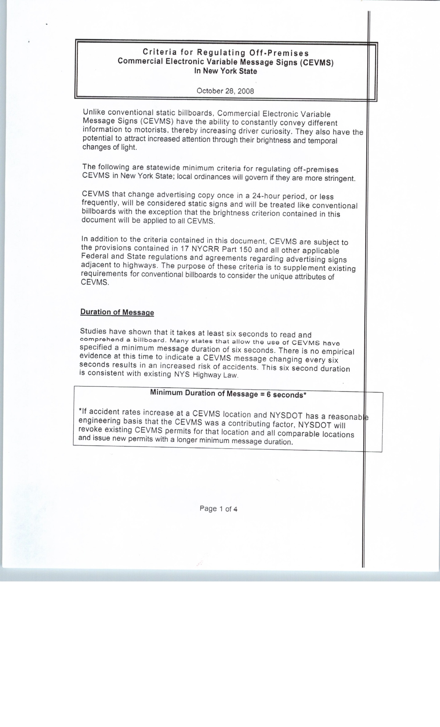
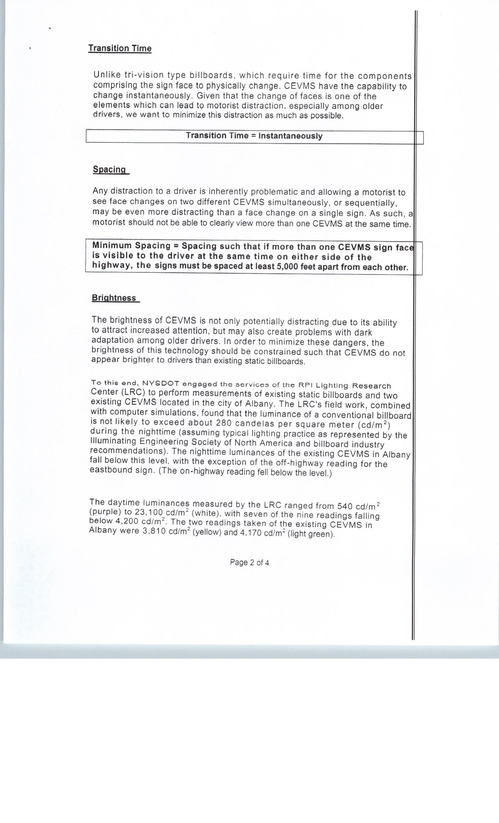
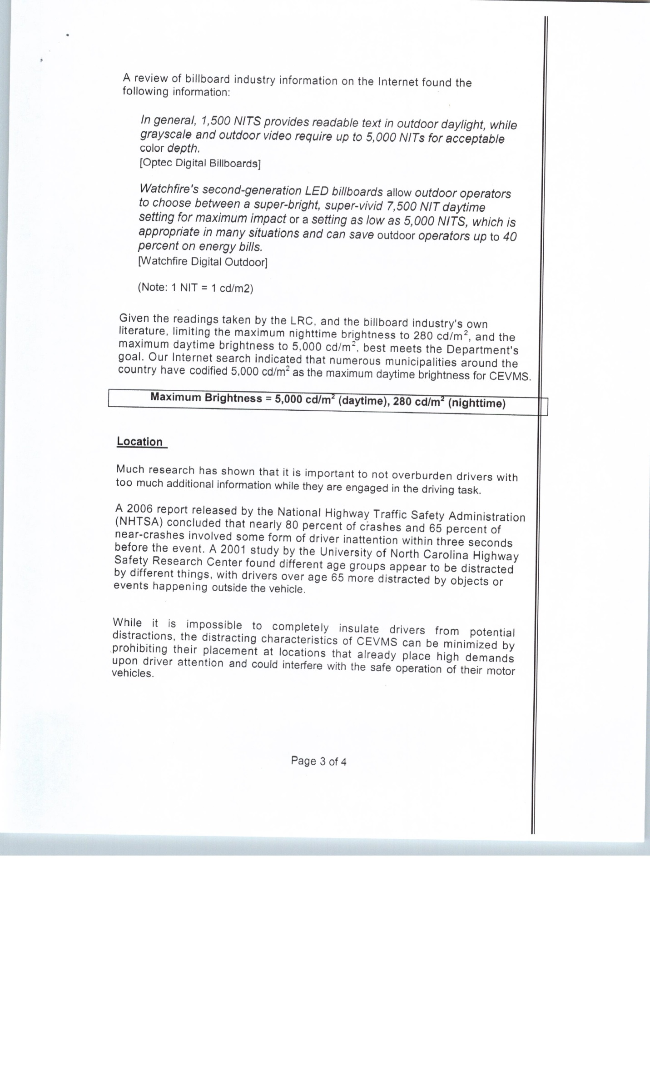
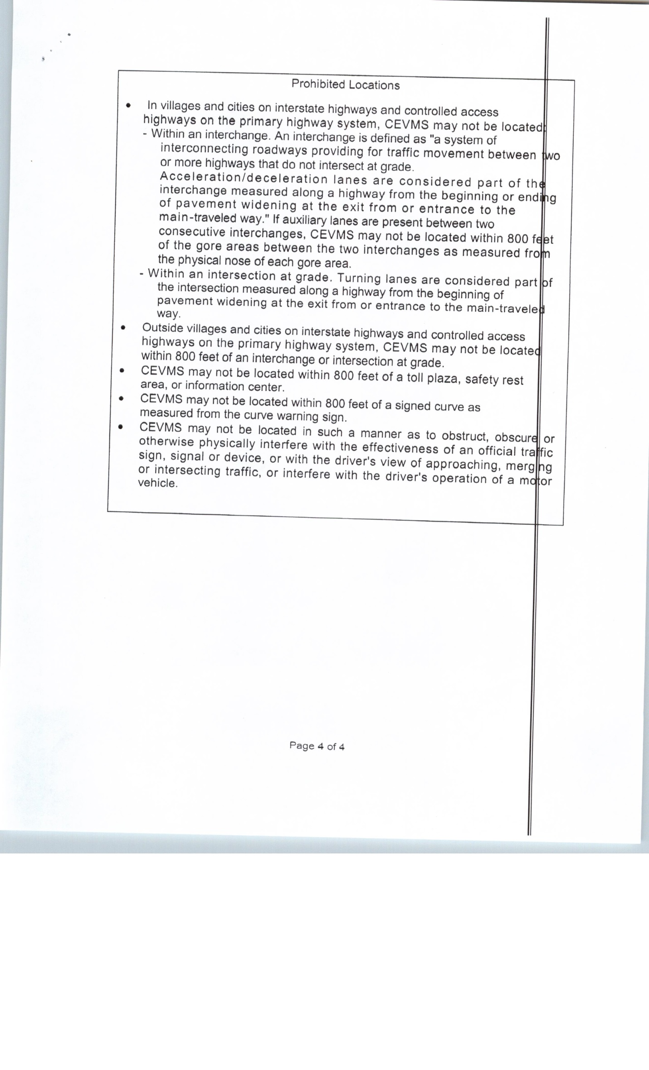
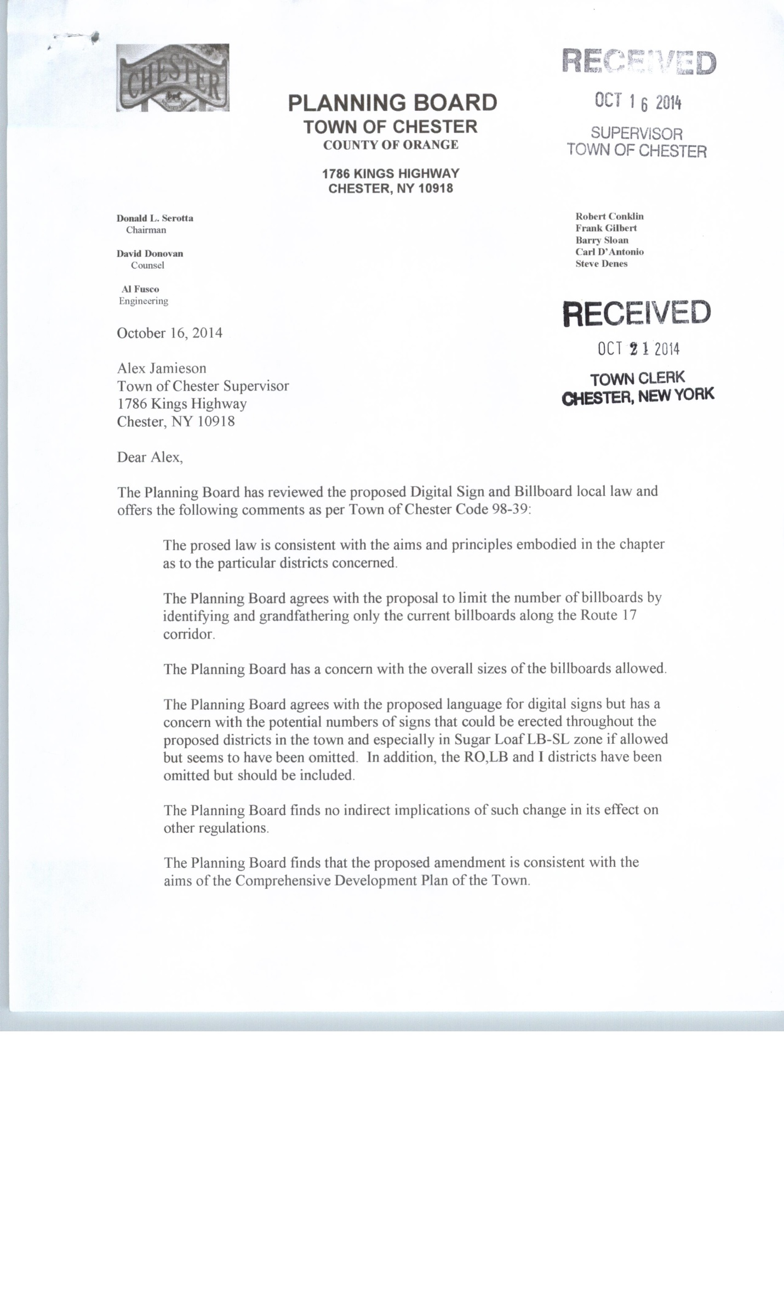
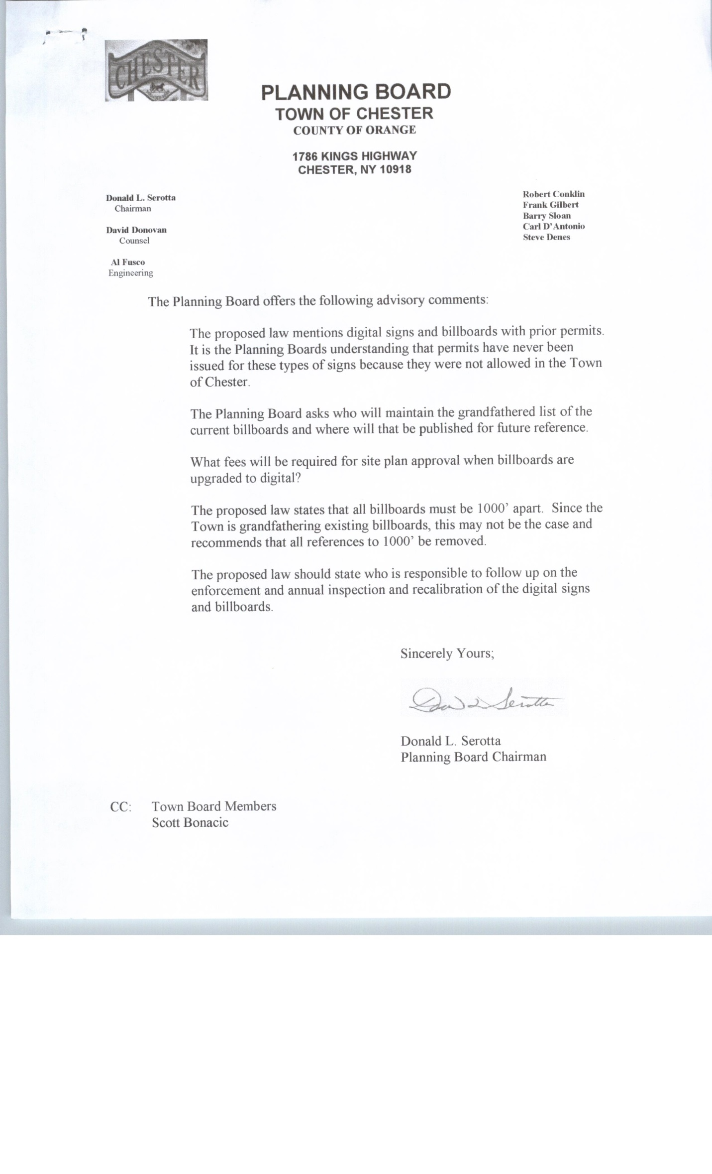
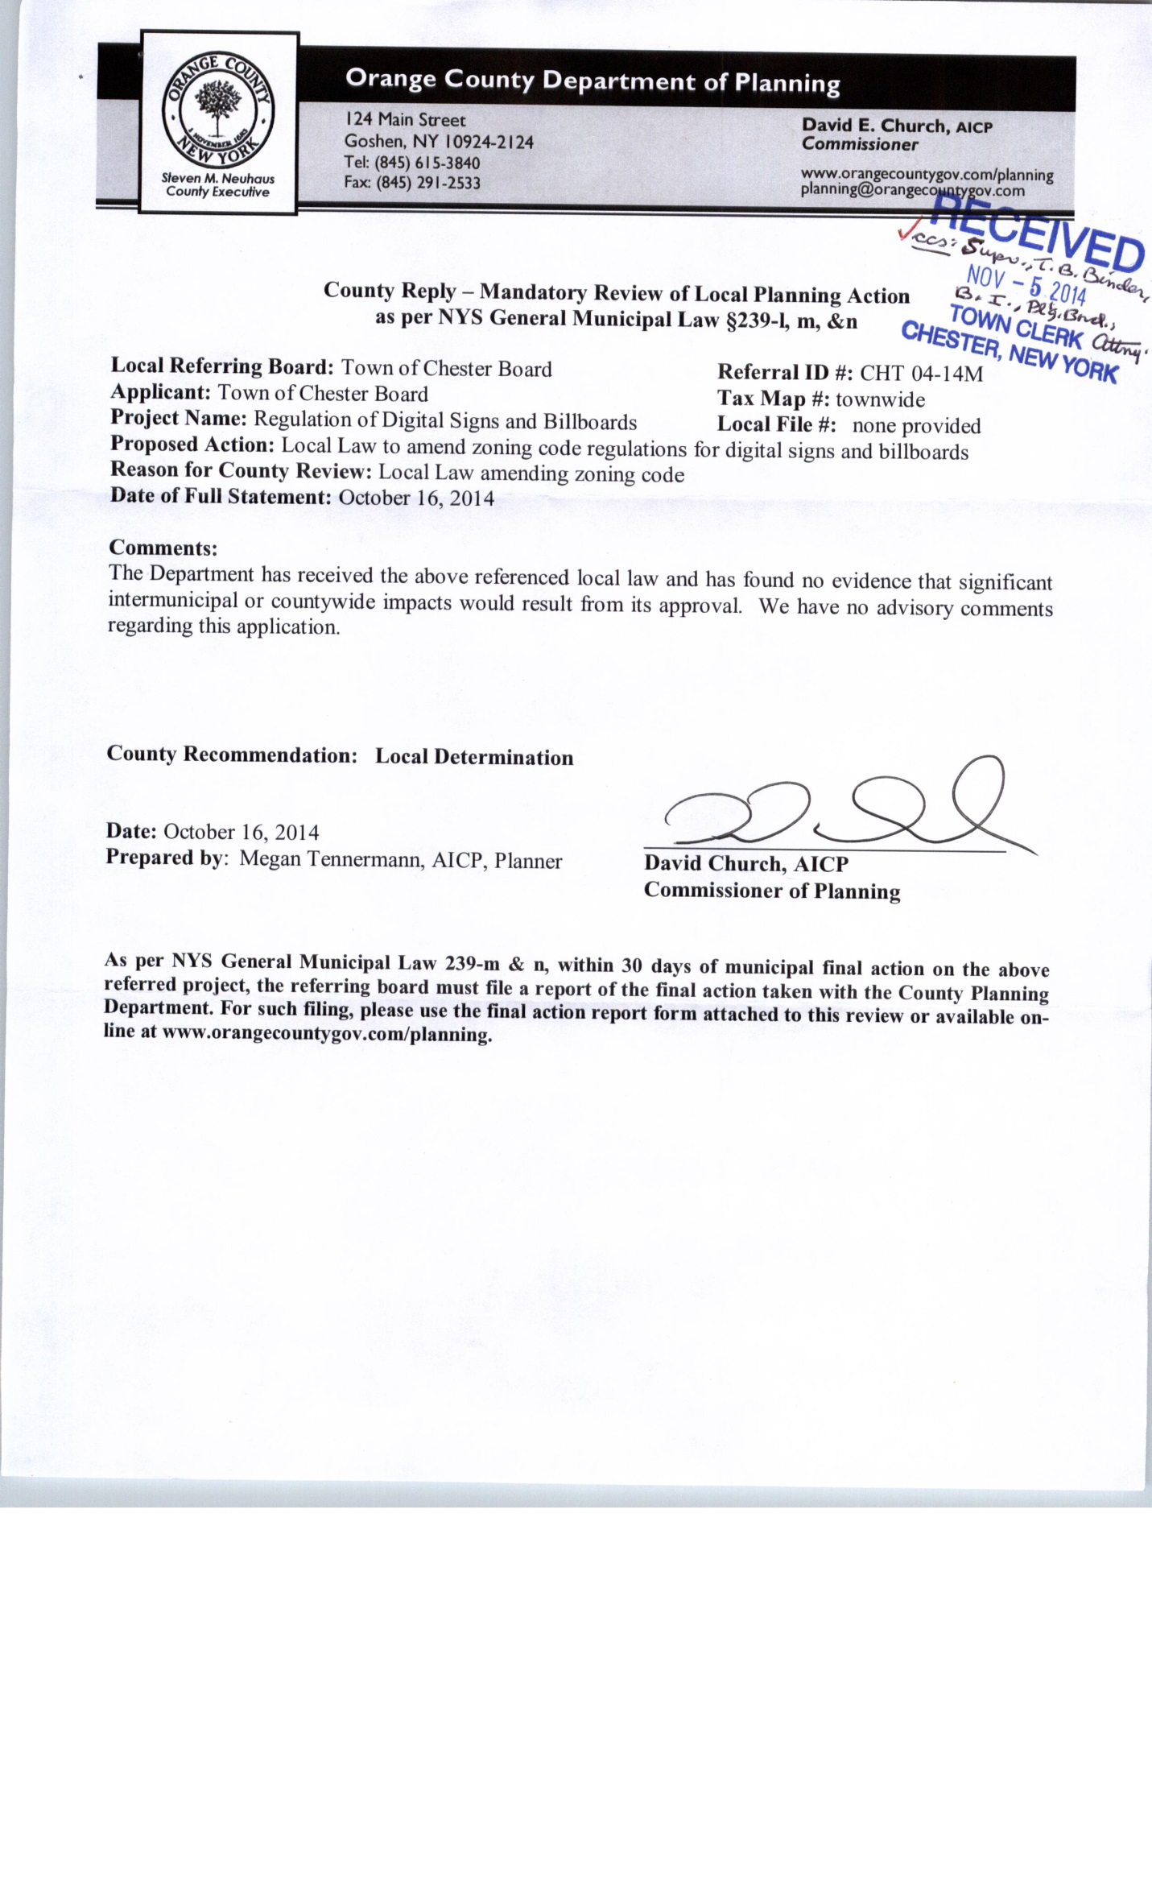

A MOTION WAS MADE BY Councilman Murray and seconded by Councilwoman Ranni to close the Public Hearing with regard to the Proposed Local Law regarding Digital Signs and Billboards. Motion carried
5-0.

ORANGE AND ROCKLAND STORM WATER SUB STATION

A MOTION WAS MADE BY Councilwoman Smith and seconded by Councilman Murray to approve and allow the Supervisor to sign the Storm Water Facility Maintenance Agreement with O&R. Motion carried 5-0.

ENCUMBRENCE OF HIGHWAY FUNDS

A MOTION WAS MADE BY Councilman Murray and seconded by Councilman Valentine to encumber $8,953.01 of the DA5130.4 to the 2015 budget for the anticipated repair of highway truck #18 as it awaits parts from the manufacturer. Motion carried 5-0.

CLOTHING BID FOR HIGHWAY AND WATER

A MOTION WAS MADE BY Councilman Murray and seconded by Councilman Valentine to accept the low clothing bid at the estimated cost of $460 p/person from Wood’s Menswear of Brentwood, L.I. Motion carried 5-0.

ELIMINATE PART TIME CLERK

A MOTION WAS MADE BY Councilwoman Smith and seconded by Councilman Valentine to eliminate a part-time clerk position from the Town of Chester. Motion carried 5-0.

ASSOCIATION OF TOWNS DELEGATE

A MOTION WAS MADE BY Councilwoman Ranni and seconded by Councilman Valentine to appoint Councilman Murray as Delegate and Supervisor Jamieson as alternate delegate to the Association’s Annual Business Meeting held on February 18, 2015.

WARWICK VALLEY HUMANE SOCIETY AGREEMENT

A MOTION WAS MADE BY Councilman Valentine and seconded by Councilwoman Smith to approve and allow Supervisor Jamieson to sign the agreement with the Warwick Valley Humane Society approved for in the 2015 budget. Motion carried 5-0.

PARK RENAMING

Supervisor Jamieson continued the discussion regarding the renaming of the Town parks. A previous motion was made to rename the Commons Park to the Charles Shaughnessy Park. A MOTION WAS MADE BY Councilwoman Ranni and seconded by Councilman Murray to rescind the renaming of the Chester Commons Park. Motion carried 4-1. Robert Valentine - Nay. Discussion: Supervisor Jamieson will contact the Shaughnessy family.

TOWN HALL HOURS

A MOTION WAS MADE BY Councilwoman Smith and seconded by Councilman Valentine to change the Town Hall business hours to Monday-Thursday, 9a.m.-6p.m. and Friday 9a.m.-1p.m., effective
February 2, 2015. Motion carried 5-0.

EDUCATION REQUESTS

A MOTION WAS MADE BY Councilman Murray and seconded by Councilman Valentine to approve PO D’Agnese to attend the Standardized Field Sobriety Testing course to be held at the Orange County Police Chiefs’ Academy from January 28 to January 30, 2015 at no cost. Motion carried 5-0.

A MOTION WAS MADE BY Councilman Murray and seconded by Councilman Valentine to approve the attendance of Sgt. Slowik to the TASER Conducted Electrical Weapon (CEW) Instructor recertification course to be held on March 17, 2015 at Cherryville, PA for a cost of $175.00 Motion carried 5-0.

TAX RECEIVER SURETY BOND

A MOTION WAS MADE BY Councilman Murray and seconded by Councilman Smith to approve, sign and file with the County of Orange the Western Surety Bond #70644089 beginning January 7, 2015 and ending January 7, 2016. Motion carried 5-0.

PARKLAND FEES TRANSFER

A MOTION WAS MADE BY Councilman Murray and seconded by Councilwoman Smith to approve the transfer of $9,668.13 from Park land fees to A-7140.2 to pay for basketball poles, nets, various electric work, ice rink netting and hockey goals, and sign posts. Motion carried 5-0.

APPOINTMENTS

A MOTION WAS MADE BY Councilwoman Smith and seconded by Councilman Murray to make the following re-appointments as per the 2015 Reorganization.

Joanne Janik, Library Board, term ending December 31, 2019
Michael Mallon, Ethics Board, term ending December 31, 2016
Lori Smith, Board of Assessment Review, term ending September 30, 2019
Vincent Finizia, Zoning Board of Appeals, term ending December 31, 2020

Motion carried 5-0.

REORGANIZATION CHANGES

A MOTION WAS MADE BY Councilwoman Smith and seconded by Councilwoman Ranni to accept the changes from the Reorganization meeting. Motion carried 5-0.

WEBSITE

Mr. Guzman of A&E Advertising addressed the Board. He stated they have 400 clients, including the Monroe Chamber of Commerce as well as school districts. He said they have been residents of Chester for 18 years, and have worked with the Town previously under Brian Jarvis’ supervision. He said they will design the website and train the person responsible for maintaining the website. He said they will host and maintain the Town’s website. Cost for maintenance runs $39.95 p/month for hosting and maintenance. He said to refer to aeadvertising.com to see their portfolio.

ORANGE COUNTY TRANSPORTATION COUNCIL

A MOTION WAS MADE BY Councilwoman Smith and seconded by Councilman Murray to give written authorization to Fusco Engineering, by Rahul Verma, P.E. to represent the Town at the Council Executive session on January 20, 2015 and Alfred E. Fusco, P.E. in subsequent sessions, and said authorization to be signed by Supervisor Jamieson. Motion carried 5-0.

STANDARD WORK DAY

A MOTION WAS MADE BY Councilwoman Smith and seconded by Councilman Murray and passed unanimously 5-0 to approve the following resolution:

BE IT RESOLVED, that the Town of Chester, Location code 30466 hereby establishes the standard work day of 6 hours per day for elected and appointed official and will report the following days worked to the New York State and Local Employees’ Retirement System based on the time keeping system records or the records of activities maintained and submitted by these officials to the clerk of this body by
April 15, 2015. Motion carried 5-0.

RESIGNATION

A MOTION WAS MADE BY Councilman Murray and seconded by Councilwoman Ranni to accept the resignation of Gabriel Wasserman as Librarian I at the Chester Library, effective Thursday,
January 15, 2015. Motion carried 5-0.

BOARD COMMENTS

Councilwoman Smith noted that the procedure for making public comments should be posted on the website. She said the speaker should come to the podium, limit their comments to three minutes and have proper dress attire. Supervisor Jamieson added that the Rules of Conduct and Decorum at Town Meetings would be posted on the website.

Councilwoman Smith asked about the new doors to be installed at the storage side of the Senior Center. Supervisor Jamieson said he would follow up with Joe Mlcoch.

Councilwoman Smith asked the status of the heating system in the library. Supervisor Jamieson stated that repairs would be made as needed as a full replacement system would need to be budgeted for.

Councilwoman Smith asked about the new building versus the addition on the existing ambulance corp. building. Supervisor Jamieson stated that the new building has been put on hold. He said there have been upgrades done to the senior center including carpets and bathrooms and work will be done on the kitchen and a new ventilating system to remove the moisture. The carpet cleaner said the carpet is an excellent one with rubber matting and that the wave system would remove the odor and would preserve the carpet. Supervisor Jamieson said he is speaking with the Town engineer about moving the Police Department into the Ambulance building. Their also has been discussion about possibly moving the Court there, requiring a small addition to the building. Councilwoman Smith asked if the discussion about the expansion was going to move forward. Supervisor Jamieson said the Police Department would be moved in 2015. As far as the addition, Supervisor Jamieson said he is looking at the expense of an addition. Supervisor Jamieson said he would like to move the employees from the lower level up to the main level. He said talks will be had this year concerning a possible building expansion.

Councilwoman Smith asked about the ambulance vehicles. Attorney Bonacic noted that it is ongoing litigation.

Councilwoman Smith said she spoke with Joe Mlcoch about the Steve Rowe property on Meadow Ave. that may require a lien on the property to get it cleaned up, as it is spilling over onto the neighbors. Councilwoman Smith said they have been taken to Court and ordered to clean up the property, but it remains as a dump area. Councilwoman Smith said a lien should be put in place to pay for the property to be cleaned up. Supervisor Jamieson said he would follow up with the Building Inspector.

Councilwoman Smith commented about the ice skating rink. She said she was there with her granddaughter recently and it was great.

Councilwoman Smith also asked about the painting of the senior center. Supervisor Jamieson said he contacted two companies and is waiting for quotes. Councilwoman asked about the wave system. The Board had motioned to purchase a system. Supervisor Jamieson said he has been advised that two systems would be required. Walter Popailo added that the room may require three to adequately do the job. He said that he expects it to be approximately $1,095 each for three.

PUBLIC COMMENTS

Walter Popailo mentioned that the ice skating rink will have hockey nets added. He said under the rink is a brand new basketball court and hockey court. There will be nets purchased for the summertime.

Walter also mentioned that every Town around has a special day each year. He suggested that the fireworks night be turned into a day block party event starting at 2pm through the fireworks show. He suggested bouncy houses, bands and vendors to make the event more of a draw to others outside of Town to support the Town businesses. He has spoken with Chief Doellinger and Chief Graziano, John Vero and the school and all are on board. Supervisor Jamieson said he spoke with Mayor Valastro and he thought it was a great idea. Walter said we would hold it on Saturday, July 11, 2015.

John Vero spoke to the Board about his meeting with Ken Haverlan, Field Representative from HCC Public Risk. He mentioned that they met with Linda Zappala, Town Clerk, Sharon Conklin, Bookkeeper, Darlene DeMarmels, Maureen Jagos, Library Director, Bill Keller, Water Operator, Anthony LaSpina, Highway Superintendent and Police Chief Doellinger. He made site visits to various locations around the Town. He liked the skate park signage and construction, as it was not over open water. He had a few recommendations which he would be forwarding to the Town in writing. Mr. Vero stated that overall Mr. Haverlan found everything looked good.

EXECUTIVE SESSION

A MOTION WAS MADE BY Councilman Murray and seconded by Councilwoman Smith to enter into Executive Session at 8:25p.m. Motion carried 5-0.

A MOTION WAS MADE BY Councilman Murray and seconded by Councilwoman Ranni to adjourn the Executive Session at 8:35p.m. Motion carried 5-0.

RESOLUTION CONCERNING ORANGE & ROCKLAND RATE INCREASE

Whereas, Orange & Rockland Utilities, Inc., (hereinafter “O & R”) as a subsidiary of an investor-owned company, must demonstrate profitability to its shareholders; and
Whereas, O&R must very occasionally request from the Public Service Commission (hereinafter “PSC”) a rate increase in order to sustain said profitability in light of increasing government fees, increasing property taxes, expanding services, inflation, and other variables; and
Whereas, the Town of Chester Town Board believes that a 6% increase to electric delivery and an 18% increase in natural gas delivery is excessive given the financial hardship that many of Chester’s taxpayers presently face; and
Whereas, the Town of Chester Town Board believes that O&R can meets its financial responsibility to its shareholders with a far lower rate increase.
Now, Therefore, Be it Resolved by the Town of Chester Town Board to oppose the O&R rate increase as it presently stands and urges the PSC to limit any increase to a more reasonable and sensitive level; and
Be It Further Resolved, that a copy of the resolution will be sent to the Secretary of the NYS Public Service Commission, Assemblyman James Skoufis, Senator William J. Larkin, Jr. And the President of Orange County Association of Towns/Cities/Villages.

Date: January 14, 2015
Moved by: Jerry Murray 2nd by Robert Valentine
Vote: 5-0 Councilman Murray, Councilwoman Ranni, Councilwoman Smith,
Councilman Valentine, Supervisor: Alex Jamieson

MOTION CARRIED

There being no further business brought before the Board, A MOTION WAS MADE BY Councilman Murray and seconded by Councilwoman Smith to adjourn the meeting at 8:40p.m. Motion carried 5-0.

Respectfully submitted,

Linda A. Zappala
Town Clerk
2015-01-14

