PLANNING BOARD
TOWN OF CHESTER
COUNTY OF ORANGE

1786 KINGS HIGHWAY
CHESTER, NY 10918

Donald L. Serotta Robert Conklin
Chairman Frank Gilbert
Barry Sloan
David Donovan Carl D’Antonio
Counsel Steve Denes
Ernie Damiani
Al Fusco
Engineering

July 6, 2015

Dimitrios Lambros
Town of Chester ZBA Chairman
1786 Kings Highway
Chester, NY 10918

Dear Dimitrios ,

Jay Samuelson representing Laviano (Aka JJLV Properties) appeared before the Planning Board on July 1, 2015 proposing a gas station and a convenience store to be located at 1831 Kings Highway. During our discussions on the proposed site plan, it was determined that the Laviano application will need to be referred to the Zoning Board of Appeals (ZBA) for:
An interpretation and/or variance to Town of Chester Zoning Code 98-29 J(2).
The Planning Board will await your decision before taking any further action. If you have any questions or need additional information, please contact me.
Sincerely Yours,
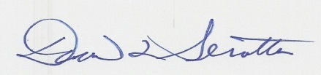
Donald L. Serotta
Town of Chester Planning Board Chairman

